NOTIFIABLE MEDICAL CONDITIONS SURVEILLANCE SYSTEM

the National Institute for Communicable Diseases

# Introduction

This report summarizes data from the National Notifiable Medical Conditions Surveillance System (NMCSS) on cases diagnosed and reported in **September 2023**. Additionally, this report includes information on the distribution of case notifications by sources, such as clinical or laboratory notifications, merged cases (**see Appendix no. 3**), and the number of reported deaths. It monitors the use of the electronic NMC Reporting Application (App) for notification, data quality, specifically the completeness and timeliness of clinical diagnosis and notifications over time, and back-captured cases notified in September 2023 (**see Appendix nos. 1 and 3**). Category 4 NMCs, COVID-19, and multi-system inflammatory syndrome (MIS-C) have been excluded from this report.

## Highlights

* A total of 7517 cases were notified in September 2023 and the majority were category 2 conditions.
* There were x average active users of the NMC App in September 2023
* Category 1 cases were reported in median (IQR) of 1.0 (0.0, 2.0) days.

## NMC Reporting application

* [NMC Reporting App](www.nmc.nicd.ac.za) is available on both web and mobile platforms
* Use recommended browsers in order to access NMC reporting App for notifications, searching of cases and reports.
* Register if you have no NMC account and you can reset the password if you have not used the application over 12 months. 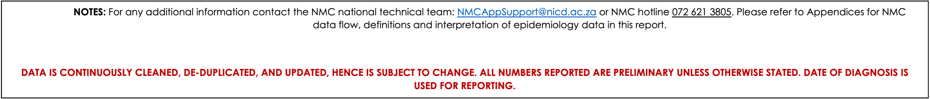

# NMC data summary, September 2023

A total of n=8588 cases were diagnosed and notified to the NMCSS in September 2023 **(See Appendix no.3 for definitions)**. There were n=7517 current notifications; the majority (n=6 687, 89%)were category 2 conditions . The provinces with the highest number of notifications were KwaZulu-Natal (n=1 962, 26%), Gauteng (n=1 764, 23%), and Western Cape (n=1 409, 19%). The provinces with the least number of notifications were Northern Cape (n=282, 3.8%), and North West (n=293, 3.9%). (**Figure 1**) There were n=1071 back captured clinical notifications diagnosed between June, 2015 and September 2023 and only notified in September 2023. The majority (n=737, 69%) of those notifications were cases TB:pulmonary notifications. (**See Appendix no.1**).

Table 1: Description of NMC notifications by case source

| **NMC Category** | **Overall**, N = 7 517 | **Clinical notifications**,  n = 5278 | **Laboratory notifications**,  n = 2050 | **Merged Cases**,  n = 189 |
| --- | --- | --- | --- | --- |
| Category 1 | 745 (9.9%) | 335 (6.3%) | 332 (16%) | 78 (41%) |
| Category 2 | 6 687 (89%) | 4 943 (94%) | 1 644 (80%) | 100 (53%) |
| Category 3 | 85 (1.1%) | 0 (0%) | 74 (3.6%) | 11 (5.8%) |

## App use

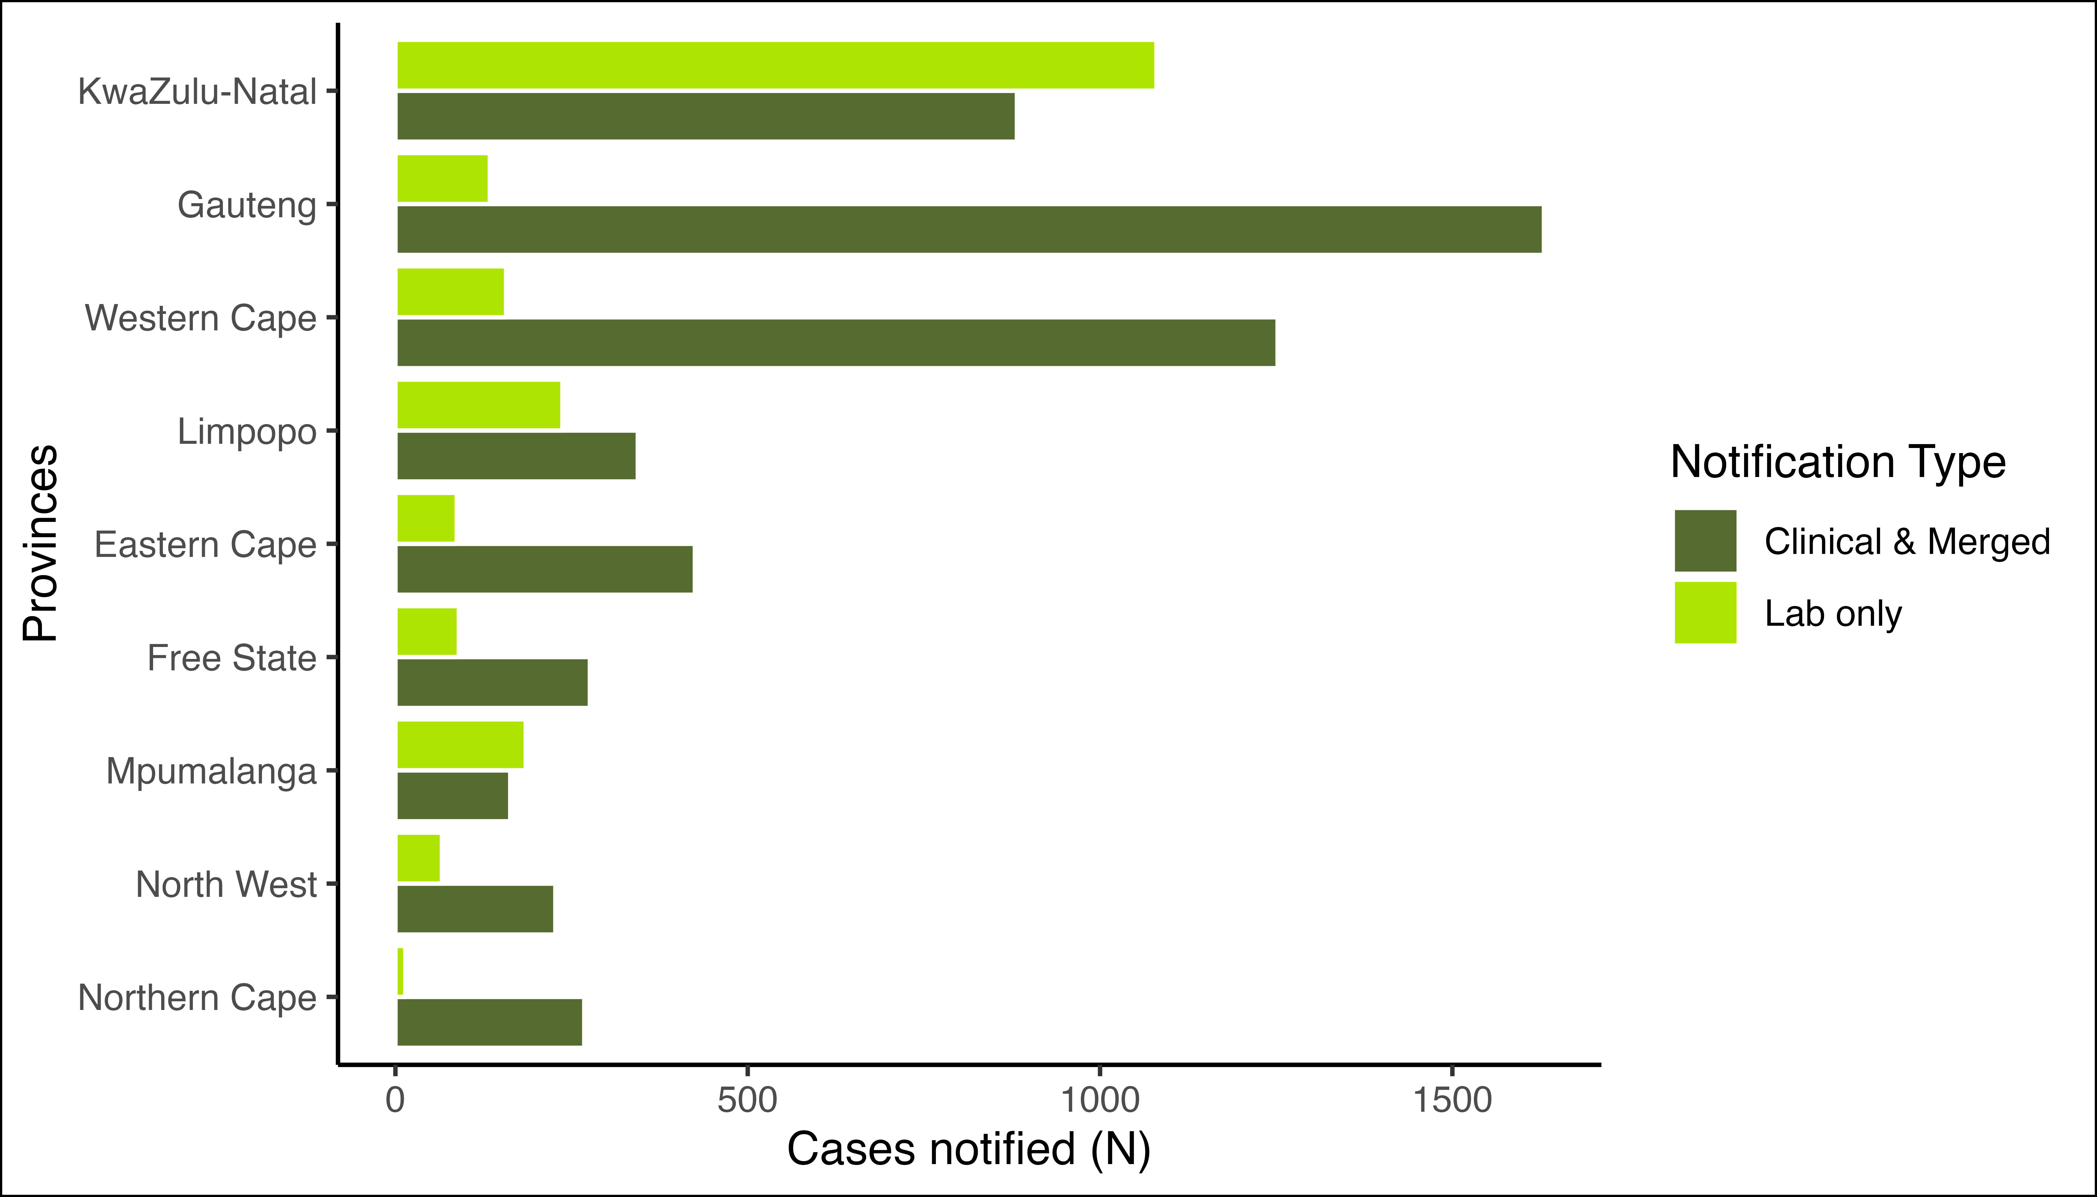

Figure 1: Distribution of notifications by province and notification type

There were 568 (10%) Clinical notifications from from the private sector (i.e. private hospitals, private practice and mining industry) compared to 4 899 (90%) in the public sector. Clinical notifications using the NMC Reporting Application made up 5193 (98%) (see Table 2 ).

Table 2: Clinical notifications notified by provinces, reporting platform, and sector

| **Province** | **Overall**, N = 5 322 | **App - Private**,  n = 564 | **App - Public**,  n = 4629 | **Paper-based - Private**,  n = 4 | **Paper-based - Public**,  n = 125 |
| --- | --- | --- | --- | --- | --- |
| GP | 1 599 (100%) | 178 (11%) | 1 417 (89%) | 1 (<0.1%) | 3 (0.2%) |
| WC | 1 217 (100%) | 76 (6.2%) | 1 075 (88%) | 1 (<0.1%) | 65 (5.3%) |
| KZN | 836 (100%) | 122 (15%) | 708 (85%) | 0 (0%) | 6 (0.7%) |
| EC | 422 (100%) | 31 (7.3%) | 371 (88%) | 0 (0%) | 20 (4.7%) |
| LP | 335 (100%) | 22 (6.6%) | 312 (93%) | 1 (0.3%) | 0 (0%) |
| FS | 274 (100%) | 45 (16%) | 228 (83%) | 1 (0.4%) | 0 (0%) |
| NC | 264 (100%) | 22 (8.3%) | 240 (91%) | 0 (0%) | 2 (0.8%) |
| NW | 227 (100%) | 47 (21%) | 157 (69%) | 0 (0%) | 23 (10%) |
| MP | 148 (100%) | 21 (14%) | 121 (82%) | 0 (0%) | 6 (4.1%) |

The majority of the notified cases were Males n(%) 4 499 (60%). Individuals in the 35-39 year age group represented the majority (894 (12%)) of notified cases (Table 3). At the time of notificaiton, approximately 1 795 (24%) of the notified cases were hospitalized, while 52 (0.7%) were transferred to another healthcare facility. There were 66 deaths notified during the reporting period with case fatality rate of 0.9%.

## Hospital Form Completeness

Table 3: Completion of hospitalisation form for patients diagnosed with category 1 conditions who were either admitted, discharged, or transferred out

|  | **Discharged** | | **Inpatient** | **Transferred** |
| --- | --- | --- | --- | --- |
| **Hospital Form Completed** | **No**, n = 34 (59%) | **Yes**, n = 24 (41%) | **Yes**, n = 259 (100%) | **No**, n = 5 (100%) |
| Acute Flaccid Paralysis | 1 (2.9%) | 1 (4.2%) | 18 (6.9%) | 2 (40%) |
| Congenital rubella syndrome | 1 (2.9%) | 0 (0%) |  |  |
| Diphtheria | 1 (2.9%) | 1 (4.2%) | 1 (0.4%) | 1 (20%) |
| Food borne illness outbreak | 4 (12%) | 0 (0%) | 9 (3.5%) |  |
| Malaria | 7 (21%) | 3 (13%) | 65 (25%) | 2 (40%) |
| Measles | 3 (8.8%) | 5 (21%) | 32 (12%) |  |
| Meningococcal Disease | 2 (5.9%) | 0 (0%) | 17 (6.6%) |  |
| Pertussis | 14 (41%) | 14 (58%) | 110 (42%) |  |
| Rubella | 1 (2.9%) | 0 (0%) | 1 (0.4%) |  |
| Enteric fever (typhoid or paratyphoid fever) |  |  | 1 (0.4%) |  |
| Listeriosis |  |  | 3 (1.2%) |  |
| Rabies |  |  | 1 (0.4%) |  |
| Waterborne illness outbreak - UNDEFINED |  |  | 1 (0.4%) |  |

## Distribution of category 1 NMCs by province and number of deaths

Table 4: Distribution of Category 1 NMC by Province

|  | **Provinces, n** | | | | | | | | | **Case Type, n(%)** | | |
| --- | --- | --- | --- | --- | --- | --- | --- | --- | --- | --- | --- | --- |
| Condition | **EC** | **FS** | **GP** | **KZN** | **LP** | **MP** | **NC** | **NW** | **WC** | **Clinical notifications** | **Laboratory notifications** | **Merged Cases** |
| Acute Flaccid Paralysis | 1 | 0 | 6 | 6 | 3 | 0 | 0 | 0 | 6 | 22 (100%) | 0 (0%) | 0 (0%) |
| Cholera | 0 | 0 | 1 | 0 | 0 | 0 | 0 | 0 | 0 | 1 (100%) | 0 (0%) | 0 (0%) |
| Congenital rubella syndrome | 0 | 0 | 0 | 3 | 1 | 0 | 0 | 0 | 0 | 0 (0%) | 3 (75%) | 1 (25%) |
| Diphtheria | 0 | 0 | 0 | 1 | 0 | 0 | 0 | 0 | 4 | 3 (60%) | 0 (0%) | 2 (40%) |
| Enteric fever (typhoid or paratyphoid fever) | 1 | 0 | 3 | 0 | 0 | 0 | 0 | 1 | 2 | 0 (0%) | 5 (71%) | 2 (29%) |
| Food borne illness outbreak | 0 | 0 | 9 | 4 | 0 | 3 | 0 | 0 | 1 | 17 (100%) | 0 (0%) | 0 (0%) |
| Listeriosis | 1 | 0 | 0 | 0 | 0 | 0 | 0 | 0 | 3 | 1 (25%) | 1 (25%) | 2 (50%) |
| Malaria | 2 | 6 | 49 | 18 | 134 | 52 | 3 | 5 | 20 | 51 (18%) | 195 (67%) | 43 (15%) |
| Measles | 1 | 4 | 35 | 22 | 4 | 7 | 1 | 0 | 34 | 86 (80%) | 16 (15%) | 6 (5.6%) |
| Meningococcal Disease | 2 | 2 | 4 | 1 | 0 | 1 | 0 | 1 | 11 | 17 (74%) | 3 (13%) | 3 (13%) |
| Pertussis | 27 | 35 | 74 | 31 | 16 | 9 | 3 | 9 | 33 | 128 (54%) | 90 (38%) | 19 (8.0%) |
| Rabies | 0 | 0 | 0 | 3 | 1 | 0 | 0 | 0 | 0 | 3 (75%) | 1 (25%) | 0 (0%) |
| Rubella | 4 | 2 | 1 | 7 | 0 | 0 | 0 | 0 | 11 | 7 (28%) | 18 (72%) | 0 (0%) |
| Waterborne illness outbreak - UNDEFINED | 0 | 0 | 0 | 0 | 0 | 0 | 0 | 0 | 1 | 1 (100%) | 0 (0%) | 0 (0%) |

The majority of category 1 notifications were for Malaria n(%) 289 (39%). The majority of Malaria cases were notified in LP n(%) 134(46.4%).

## Distribution of category 2 NMCs by province and number of deaths

Table 5: Distribution of Category 2 NMC by Province

|  | **Provinces, n** | | | | | | | | | **Case Type, n(%)** | | |
| --- | --- | --- | --- | --- | --- | --- | --- | --- | --- | --- | --- | --- |
| Condition | **EC** | **FS** | **GP** | **KZN** | **LP** | **MP** | **NC** | **NW** | **WC** | **Clinical notifications** | **Laboratory notifications** | **Merged Cases** |
| Agricultural or stock remedy poisoning | 2 | 5 | 62 | 0 | 6 | 3 | 1 | 5 | 3 | 87 (100%) | 0 (0%) | 0 (0%) |
| Bilharzia (schistosomiasis) | 9 | 0 | 16 | 370 | 116 | 120 | 0 | 3 | 19 | 31 (4.7%) | 600 (92%) | 22 (3.4%) |
| Congenital syphilis | 0 | 1 | 1 | 10 | 0 | 0 | 1 | 0 | 9 | 12 (55%) | 2 (9.1%) | 8 (36%) |
| Haemophilus influenzae type B | 0 | 0 | 3 | 0 | 0 | 0 | 1 | 0 | 1 | 4 (80%) | 1 (20%) | 0 (0%) |
| Hepatitis A | 10 | 18 | 58 | 83 | 31 | 21 | 9 | 14 | 109 | 48 (14%) | 248 (70%) | 57 (16%) |
| Hepatitis B | 37 | 48 | 47 | 694 | 5 | 8 | 17 | 49 | 13 | 111 (12%) | 792 (86%) | 15 (1.6%) |
| Hepatitis C | 0 | 1 | 4 | 1 | 0 | 0 | 0 | 0 | 1 | 6 (86%) | 1 (14%) | 0 (0%) |
| Maternal death (pregnancy, childbirth and puerperium) | 0 | 0 | 4 | 0 | 3 | 0 | 0 | 1 | 0 | 8 (100%) | 0 (0%) | 0 (0%) |
| Soil transmitted helminths | 0 | 0 | 1 | 0 | 0 | 0 | 0 | 0 | 0 | 1 (100%) | 0 (0%) | 0 (0%) |
| Tuberculosis: extensively drug -resistant (XDR -TB) | 0 | 0 | 2 | 3 | 0 | 0 | 0 | 0 | 0 | 5 (100%) | 0 (0%) | 0 (0%) |
| Tuberculosis: multidrug- resistant (MDR -TB) | 16 | 6 | 48 | 29 | 1 | 1 | 5 | 1 | 23 | 130 (100%) | 0 (0%) | 0 (0%) |
| Tuberculosis:extra-pulmonary | 95 | 42 | 468 | 202 | 39 | 17 | 42 | 54 | 219 | 1 178 (100%) | 0 (0%) | 0 (0%) |
| Tuberculosis:pulmonary | 366 | 218 | 1 268 | 684 | 249 | 119 | 297 | 170 | 1 018 | 4 389 (100%) | 0 (0%) | 0 (0%) |

The majority of category 2 notifications were for Tuberculosis:pulmonary n(%) 4 389 (57%). The majority of Tuberculosis:pulmonary cases were notified in GP n(%) 1268(28.9%).

## The average active users on the NMC App

*Insert chart from excel*

## Data quality

**Completeness** refers to the proportion of complete data entries per variable in the dataset among clinical and merged notifications. In September 2023, there was an increase in completeness of date of diagnosis and patient folder number, while demographic details and patient vital status remain unchanged captured compared to x 2023.

**Timeliness** is measured by the number of days from the time of diagnosis of the NMC to the time of notification. Overall, it took a median (IQR) of 1.0 (0.0, 2.0) days to report category 1 NMCs.

Table 6: NMC data completeness on both reporting platforms,

|  | **App**, N = 5 193 | **Paper-based**, N = 129 |
| --- | --- | --- |
| **Folder Number** | 5 193 (100%) | 129 (100%) |
| **First Name** | 5 193 (100%) | 129 (100%) |
| **Surname** | 5 193 (100%) | 129 (100%) |
| **Symptom Onset Date** | 5 059 (97%) | 123 (95%) |
| **Date of Diagnosis** | 5 193 (100%) | 129 (100%) |
| **Outcome** | 5 193 (100%) | 129 (100%) |

### ID number completeness

Table 7: Length of ID numbers inputted on NMC system

| **Length of ID number** | **Android**, N = 1 7671 | **Microstrategy/SDW**, N = 2 1951 | **Paper-based**, N = 1291 | **Web**, N = 3 0301 | **iOS**, N = 3961 |
| --- | --- | --- | --- | --- | --- |
| 0 | 663 (38%) | 2 165 (99%) | 81 (63%) | 967 (32%) | 180 (45%) |
| 2 | 0 (0%) | 0 (0%) | 0 (0%) | 0 (0%) | 1 (0.3%) |
| 6 | 0 (0%) | 1 (<0.1%) | 0 (0%) | 224 (7.4%) | 24 (6.1%) |
| 8 | 0 (0%) | 0 (0%) | 0 (0%) | 36 (1.2%) | 3 (0.8%) |
| 9 | 0 (0%) | 0 (0%) | 0 (0%) | 11 (0.4%) | 0 (0%) |
| 10 | 0 (0%) | 0 (0%) | 0 (0%) | 46 (1.5%) | 2 (0.5%) |
| 11 | 0 (0%) | 0 (0%) | 0 (0%) | 2 (<0.1%) | 0 (0%) |
| 12 | 0 (0%) | 0 (0%) | 0 (0%) | 16 (0.5%) | 0 (0%) |
| 13 | 1 104 (62%) | 29 (1.3%) | 48 (37%) | 1 728 (57%) | 186 (47%) |
| Unknown | 0 | 0 | 0 | 0 | 0 |
| 1n (%) | | | | | |

### Symptomatology

Table 8: Symptoms of patients clinically notified and merged with lab notifications to the NMC

| **Characteristic** | **Overall**, N = 5 4671 | **1**, N = 4131 | **2**, N = 5 0431 | **3**, N = 111 |
| --- | --- | --- | --- | --- |
| Cough | 2 674 (49%) | 61 (15%) | 2 613 (52%) | 0 (0%) |
| No Symptoms Reported | 1 595 (29%) | 120 (29%) | 1 467 (29%) | 8 (73%) |
| Loss of weight | 1 592 (29%) | 0 (0%) | 1 592 (32%) | 0 (0%) |
| Loss of appetite | 1 142 (21%) | 8 (1.9%) | 1 134 (22%) | 0 (0%) |
| Night Sweats | 1 002 (18%) | 0 (0%) | 1 002 (20%) | 0 (0%) |
| Fever | 911 (17%) | 113 (27%) | 798 (16%) | 0 (0%) |
| Chest pains | 891 (16%) | 0 (0%) | 891 (18%) | 0 (0%) |
| Shortness of breath | 455 (8.3%) | 0 (0%) | 455 (9.0%) | 0 (0%) |
| Flu like symptoms | 384 (7.0%) | 9 (2.2%) | 375 (7.4%) | 0 (0%) |
| Weakness | 364 (6.7%) | 0 (0%) | 364 (7.2%) | 0 (0%) |
| Muscle weakness | 356 (6.5%) | 16 (3.9%) | 340 (6.7%) | 0 (0%) |
| Other | 326 (6.0%) | 6 (1.5%) | 317 (6.3%) | 3 (27%) |
| Maculopapular rash | 76 (1.4%) | 76 (18%) | 0 (0%) | 0 (0%) |
| Paroxysmal coughing | 76 (1.4%) | 76 (18%) | 0 (0%) | 0 (0%) |
| Vomiting | 47 (0.9%) | 47 (11%) | 0 (0%) | 0 (0%) |
| Headache | 46 (0.8%) | 46 (11%) | 0 (0%) | 0 (0%) |
| Conjuctivitis | 43 (0.8%) | 43 (10%) | 0 (0%) | 0 (0%) |
| Inspirational whoop | 42 (0.8%) | 42 (10%) | 0 (0%) | 0 (0%) |
| Tiredness / Body malaise | 25 (0.5%) | 25 (6.1%) | 0 (0%) | 0 (0%) |
| Acute febrile illness | 24 (0.4%) | 24 (5.8%) | 0 (0%) | 0 (0%) |
| Rice-water stools | 0 (0%) | 0 (0%) | 0 (0%) | 0 (0%) |
| Coryza (running nose) | 0 (0%) | 0 (0%) | 0 (0%) | 0 (0%) |
| 1n (%) | | | | |

# Conclusion

The majority of notifications were clinical notifications. The increase in average active users and newly registered users over time is an indication of an increase in the acceptance of the NMC App in the provinces. The completeness of patient clinical details and patient demographic details have improved, due to the application of mandatory fields on the NMC App. There was a delay in reporting tuberculosis cases. The data harmonization processes between the current and improved NMC system are underway to improve reporting.

# Recommendations

* We recommend the expedition of NMC App “whitelisting” on the provincial departmental intranet to make the electronic notification platform more accessible to health facilities.
* We recommend that clinicians should complete all patient clinical and demographic details to improve completeness.
* NMC Trainers to emphasize the importance of timeous reporting of Category 1 and 2 NMCs, in order to ensure real-time availability of data for public health action.

# Appendices

## Appendix no.1: Back captured clinical notifications

Table 9: Back captured notifications by reporting province

|  | **Overall** | **Province** | | | | | | | | | **Case Source** | | | | |
| --- | --- | --- | --- | --- | --- | --- | --- | --- | --- | --- | --- | --- | --- | --- | --- |
| **Condition** | **Overall**, n = 1071 | **EC**, n = 78 | **FS**, n = 27 | **GP**, n = 409 | **KZN**, n = 213 | **LP**, n = 29 | **MP**, n = 15 | **NC**, n = 98 | **NW**, n = 20 | **WC**, n = 182 | **Android**,  n = 222 | **Microstrategy/SDW**,  n = 1 | **Paper-based**,  n = 10 | **Web**,  n = 790 | **iOS**,  n = 48 |
| Agricultural or stock remedy poisoning | 3 (0.3%) | 0 | 0 | 1 | 0 | 0 | 0 | 0 | 2 | 0 | 1 | 0 | 0 | 2 | 0 |
| Bilharzia (schistosomiasis) | 10 (0.9%) | 0 | 0 | 0 | 2 | 8 | 0 | 0 | 0 | 0 | 9 | 0 | 0 | 1 | 0 |
| Hepatitis A | 1 (<0.1%) | 0 | 0 | 1 | 0 | 0 | 0 | 0 | 0 | 0 | 0 | 1 | 0 | 0 | 0 |
| Hepatitis B | 25 (2.3%) | 2 | 0 | 7 | 12 | 1 | 0 | 1 | 1 | 1 | 4 | 0 | 0 | 12 | 9 |
| Hepatitis C | 1 (<0.1%) | 0 | 0 | 1 | 0 | 0 | 0 | 0 | 0 | 0 | 1 | 0 | 0 | 0 | 0 |
| Malaria | 1 (<0.1%) | 0 | 0 | 0 | 0 | 1 | 0 | 0 | 0 | 0 | 1 | 0 | 0 | 0 | 0 |
| Maternal death (pregnancy, childbirth and puerperium) | 3 (0.3%) | 0 | 0 | 1 | 0 | 2 | 0 | 0 | 0 | 0 | 0 | 0 | 0 | 2 | 1 |
| Pertussis | 1 (<0.1%) | 0 | 0 | 0 | 0 | 1 | 0 | 0 | 0 | 0 | 0 | 0 | 0 | 1 | 0 |
| Tuberculosis: extensively drug -resistant (XDR -TB) | 1 (<0.1%) | 0 | 0 | 0 | 1 | 0 | 0 | 0 | 0 | 0 | 0 | 0 | 0 | 1 | 0 |
| Tuberculosis: multidrug- resistant (MDR -TB) | 27 (2.5%) | 1 | 1 | 16 | 8 | 0 | 0 | 1 | 0 | 0 | 10 | 0 | 0 | 17 | 0 |
| Tuberculosis:extra-pulmonary | 261 (24%) | 12 | 3 | 114 | 63 | 5 | 0 | 9 | 4 | 51 | 41 | 0 | 1 | 215 | 4 |
| Tuberculosis:pulmonary | 737 (69%) | 63 | 23 | 268 | 127 | 11 | 15 | 87 | 13 | 130 | 155 | 0 | 9 | 539 | 34 |

Table 10: Back captured notifications by reporting case source

|  | **Overall** | **Case Source** | | | | |
| --- | --- | --- | --- | --- | --- | --- |
|  | **N = 1 071** | **Android**, N = 222 | **Microstrategy/SDW**, N = 1 | **Paper-based**, N = 10 | **Web**, N = 790 | **iOS**, N = 48 |
| Agricultural or stock remedy poisoning | 3 (0.3%) | 1 | 0 | 0 | 2 | 0 |
| Bilharzia (schistosomiasis) | 10 (0.9%) | 9 | 0 | 0 | 1 | 0 |
| Hepatitis A | 1 (<0.1%) | 0 | 1 | 0 | 0 | 0 |
| Hepatitis B | 25 (2.3%) | 4 | 0 | 0 | 12 | 9 |
| Hepatitis C | 1 (<0.1%) | 1 | 0 | 0 | 0 | 0 |
| Malaria | 1 (<0.1%) | 1 | 0 | 0 | 0 | 0 |
| Maternal death (pregnancy, childbirth and puerperium) | 3 (0.3%) | 0 | 0 | 0 | 2 | 1 |
| Pertussis | 1 (<0.1%) | 0 | 0 | 0 | 1 | 0 |
| Tuberculosis: extensively drug -resistant (XDR -TB) | 1 (<0.1%) | 0 | 0 | 0 | 1 | 0 |
| Tuberculosis: multidrug- resistant (MDR -TB) | 27 (2.5%) | 10 | 0 | 0 | 17 | 0 |
| Tuberculosis:extra-pulmonary | 261 (24%) | 41 | 0 | 1 | 215 | 4 |
| Tuberculosis:pulmonary | 737 (69%) | 155 | 0 | 9 | 539 | 34 |

## Appendix no.2: Summary of NMCSS Data Flow

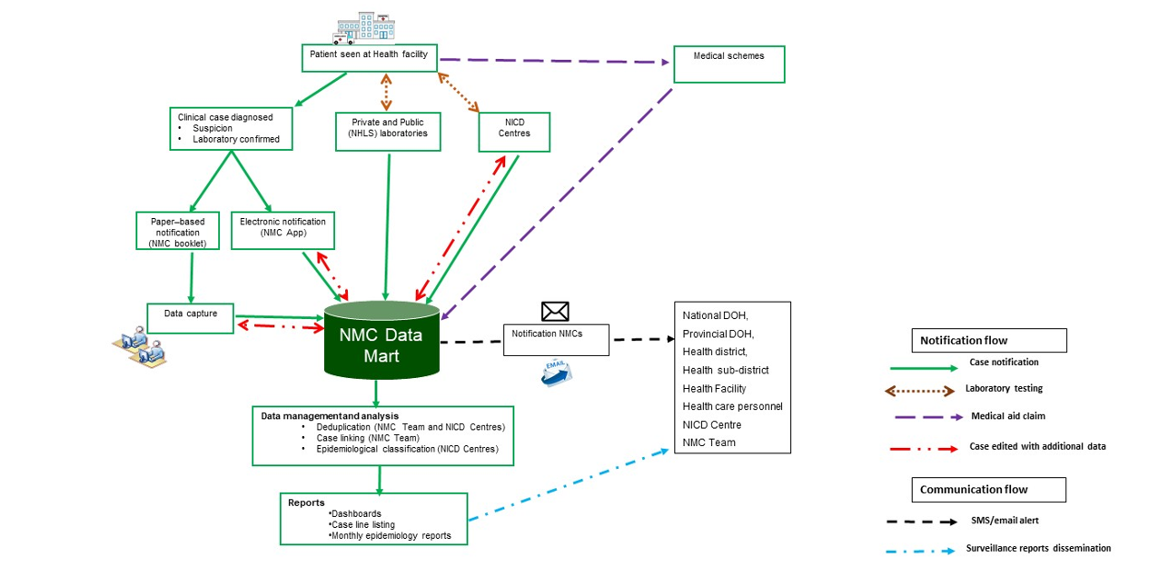

## Appendix no.3: NMC Categories, and Case Classification definitions

**NMC categories**

**Category 1**: NMCs notified by the most rapid means available upon diagnosis, followed by a written or electronic notification to the Department of Health within 24 hours of diagnosis by healthcare providers, private health laboratories or public health laboratories. These conditions must be notified based on clinical suspicion irrespective of laboratory confirmation.

**Category 2**: NMCs notified through a written or an electronic notification to the Department of Health of clinical or laboratory diagnosis within 7 days by healthcare providers, private health laboratories or public health laboratories.

**Category 3**: NMCs notified through a written or electronic notification to the Department of Health within 7 days of diagnosis by public and private health laboratories.

**Category 4**: NMCs notified through a written or electronic notification to the Department of Health within 1 month of diagnosis by public and private health laboratories.

**Case Classification definitions**

**Clinical case**: are cases reported to the NMC by health care providers at facilities, either through completion of a paper form that is faxed, emailed to National Institute of Communicable Diseases (NICD), or by direct data entry into the NMC application on a PC, laptop or mobile device. The diagnosis is made by the clinician on the basis of case definitions published on the NICD website.

**Laboratory case**: are cases that are downloaded into the NMC database directly from the National Health Laboratory Services (NHLS) laboratory information system. The NMC application applies the case definitions that are published on the NICD website. Private sector data is being sourced.

**Merged cases**: are cases where a case was notified by health care provider at the facility (a ‘clinical case’) AND the laboratory issued a report with a positive result for the same case (a ’laboratory case). The NMC App is set up to automatically detect and link clinical and laboratory case notifications. The NICD specialist Centres and NMC data team review all cases and manually link any remaining clinical and laboratory cases

**Notification capture times defintions**

**Current notification**: All cases diagnosed and notified in the current month

**Delayed notification**: All cases diagnosed in the last 14 days from the previous month

**Back capture notification**: All cases diagnosed in previous months and before the last 14 days of the previous month.

## Appendix no.4: Incidence analysis based on notification data

**Methodological note**: Population estimates are taken from StatSA. A multiple linear regression model with natural splines (4 degrees of freedom) to estimate the population for the reporting month was implemented for incidence calculations. Incidence is taken as the number of notificatiosn reported to the NMC after cleanign and deduplication. Case definitions are not strictly applied.

*insert exploratory analysis here*

# Cases and incidence by province

## Category 1

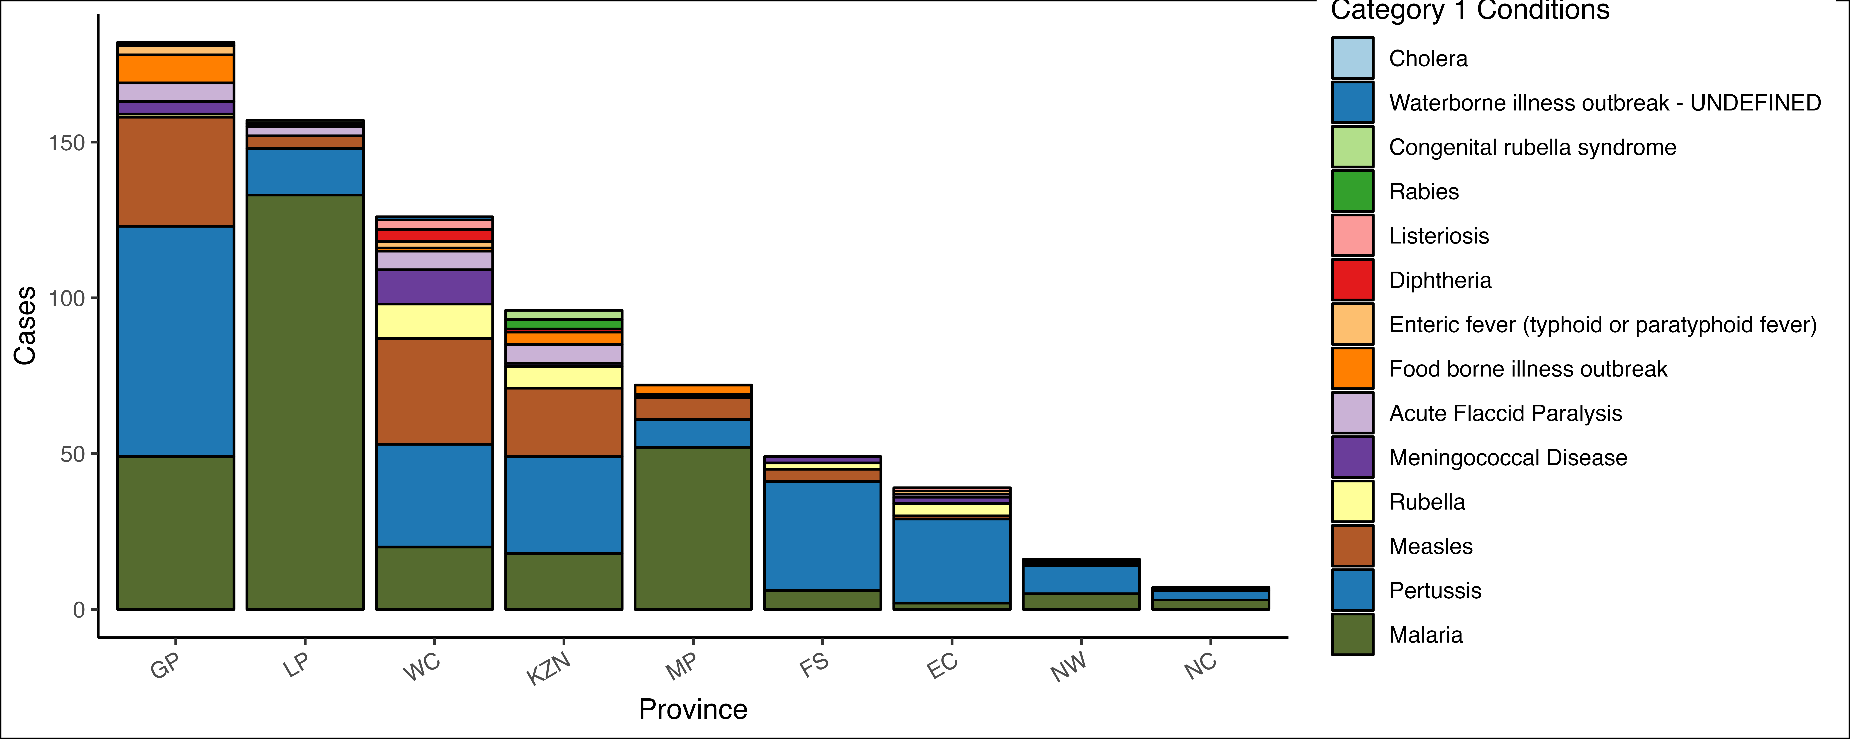

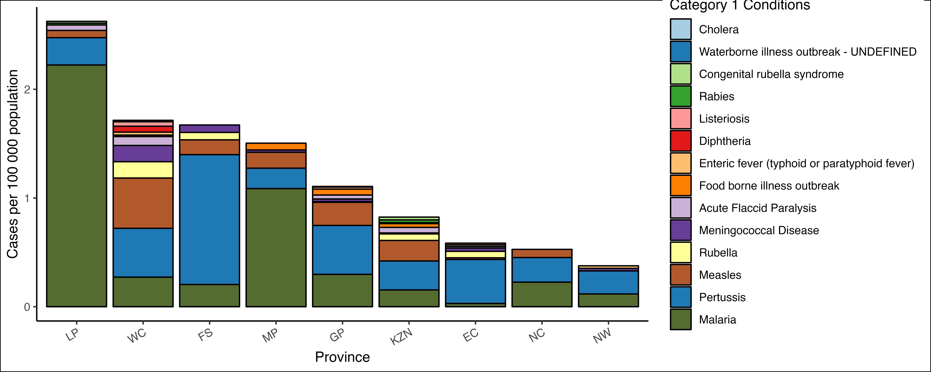

Table 11:

|  | **GP pop = 16 451 506** | | **LP pop = 5 981 583** | | **WC pop = 7 348 756** | | **KZN pop = 11 646 522** | | **MP pop = 4 786 528** | | **FS pop = 2 931 570** | | **EC pop = 6 670 455** | | **NW pop = 4 251 241** | | **NC pop = 1 326 746** | |
| --- | --- | --- | --- | --- | --- | --- | --- | --- | --- | --- | --- | --- | --- | --- | --- | --- | --- | --- |
| **Condition**1 | **c**1 | **i**1 | **c**1 | **i**1 | **c**1 | **i**1 | **c**1 | **i**1 | **c**1 | **i**1 | **c**1 | **i**1 | **c**1 | **i**1 | **c**1 | **i**1 | **c**1 | **i**1 |
| **Cholera** | **1** | 0.01 |  | - |  | - |  | - |  | - |  | - |  | - |  | - |  | - |
| **Waterborne illness outbreak - UNDEFINED** |  | - |  | - | **1** | 0.01 |  | - |  | - |  | - |  | - |  | - |  | - |
| **Congenital rubella syndrome** |  | - | **1** | 0.02 |  | - | **3** | 0.03 |  | - |  | - |  | - |  | - |  | - |
| **Rabies** |  | - | **1** | 0.02 |  | - | **3** | 0.03 |  | - |  | - |  | - |  | - |  | - |
| **Listeriosis** |  | - |  | - | **3** | 0.04 |  | - |  | - |  | - | **1** | 0.01 |  | - |  | - |
| **Diphtheria** |  | - |  | - | **4** | 0.05 | **1** | 0.01 |  | - |  | - |  | - |  | - |  | - |
| **Enteric fever (typhoid or paratyphoid fever)** | **3** | 0.02 |  | - | **2** | 0.03 |  | - |  | - |  | - | **1** | 0.01 | **1** | 0.02 |  | - |
| **Food borne illness outbreak** | **9** | 0.05 |  | - | **1** | 0.01 | **4** | 0.03 | **3** | 0.06 |  | - |  | - |  | - |  | - |
| **Acute Flaccid Paralysis** | **6** | 0.04 | **3** | 0.05 | **6** | 0.08 | **6** | 0.05 |  | - |  | - | **1** | 0.01 |  | - |  | - |
| **Meningococcal Disease** | **4** | 0.02 |  | - | **11** | 0.15 | **1** | 0.01 | **1** | 0.02 | **2** | 0.07 | **2** | 0.03 | **1** | 0.02 |  | - |
| **Rubella** | **1** | 0.01 |  | - | **11** | 0.15 | **7** | 0.06 |  | - | **2** | 0.07 | **4** | 0.06 |  | - |  | - |
| **Measles** | **35** | 0.21 | **4** | 0.07 | **34** | 0.46 | **22** | 0.19 | **7** | 0.15 | **4** | 0.14 | **1** | 0.01 |  | - | **1** | 0.08 |
| **Pertussis** | **74** | 0.45 | **15** | 0.25 | **33** | 0.45 | **31** | 0.27 | **9** | 0.19 | **35** | 1.2 | **27** | 0.40 | **9** | 0.21 | **3** | 0.23 |
| **Malaria** | **49** | 0.30 | **133** | 2.2 | **20** | 0.27 | **18** | 0.15 | **52** | 1.1 | **6** | 0.20 | **2** | 0.03 | **5** | 0.12 | **3** | 0.23 |
| 1c = cases, i = incidence | | | | | | | | | | | | | | | | | | |

## Category 2

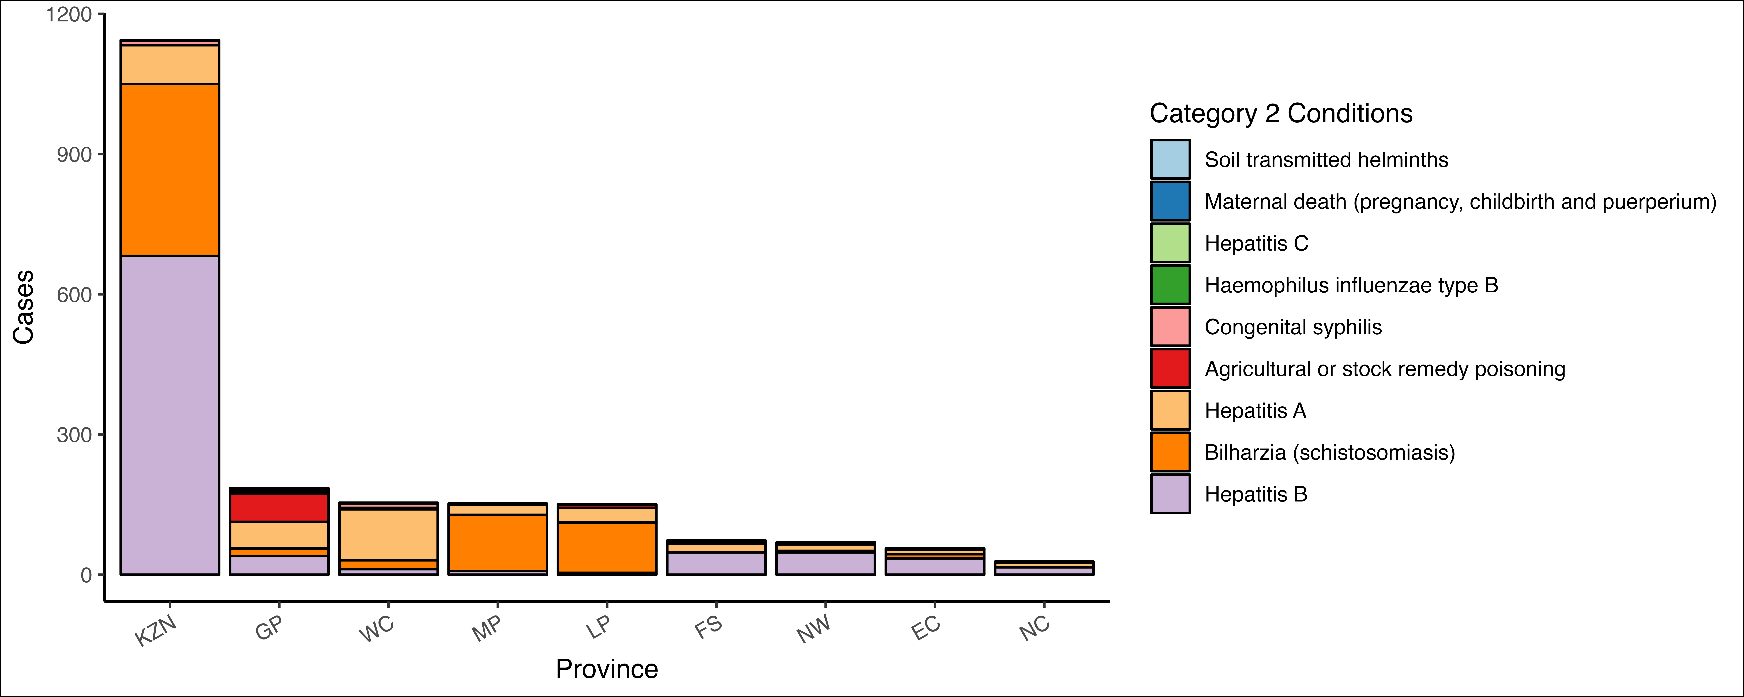

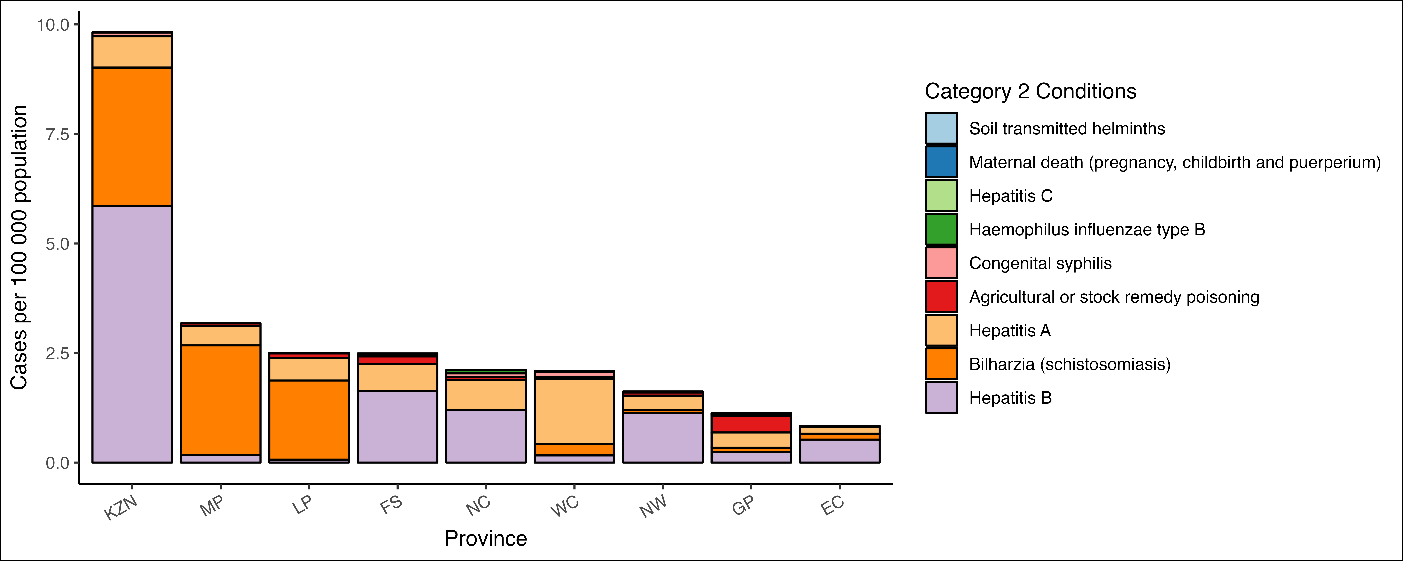

Table 12:

|  | **KZN pop = 11 646 522** | | **GP pop = 16 451 506** | | **WC pop = 7 348 756** | | **MP pop = 4 786 528** | | **LP pop = 5 981 583** | | **FS pop = 2 931 570** | | **NW pop = 4 251 241** | | **EC pop = 6 670 455** | | **NC pop = 1 326 746** | |
| --- | --- | --- | --- | --- | --- | --- | --- | --- | --- | --- | --- | --- | --- | --- | --- | --- | --- | --- |
| **Condition**1 | **c**1 | **i**1 | **c**1 | **i**1 | **c**1 | **i**1 | **c**1 | **i**1 | **c**1 | **i**1 | **c**1 | **i**1 | **c**1 | **i**1 | **c**1 | **i**1 | **c**1 | **i**1 |
| **Soil transmitted helminths** |  | - | **1** | 0.01 |  | - |  | - |  | - |  | - |  | - |  | - |  | - |
| **Maternal death (pregnancy, childbirth and puerperium)** |  | - | **3** | 0.02 |  | - |  | - | **1** | 0.02 |  | - | **1** | 0.02 |  | - |  | - |
| **Hepatitis C** | **1** | 0.01 | **3** | 0.02 | **1** | 0.01 |  | - |  | - | **1** | 0.03 |  | - |  | - |  | - |
| **Haemophilus influenzae type B** |  | - | **3** | 0.02 | **1** | 0.01 |  | - |  | - |  | - |  | - |  | - | **1** | 0.08 |
| **Congenital syphilis** | **10** | 0.09 | **1** | 0.01 | **9** | 0.12 |  | - |  | - | **1** | 0.03 |  | - |  | - | **1** | 0.08 |
| **Agricultural or stock remedy poisoning** |  | - | **61** | 0.37 | **3** | 0.04 | **3** | 0.06 | **6** | 0.10 | **5** | 0.17 | **3** | 0.07 | **2** | 0.03 | **1** | 0.08 |
| **Hepatitis A** | **83** | 0.71 | **57** | 0.35 | **109** | 1.5 | **21** | 0.44 | **31** | 0.52 | **18** | 0.61 | **14** | 0.33 | **10** | 0.15 | **9** | 0.68 |
| **Bilharzia (schistosomiasis)** | **368** | 3.2 | **16** | 0.10 | **19** | 0.26 | **120** | 2.5 | **108** | 1.8 |  | - | **3** | 0.07 | **9** | 0.13 |  | - |
| **Hepatitis B** | **682** | 5.9 | **40** | 0.24 | **12** | 0.16 | **8** | 0.17 | **4** | 0.07 | **48** | 1.6 | **48** | 1.1 | **35** | 0.52 | **16** | 1.2 |
| 1c = cases, i = incidence | | | | | | | | | | | | | | | | | | |

## Category 3



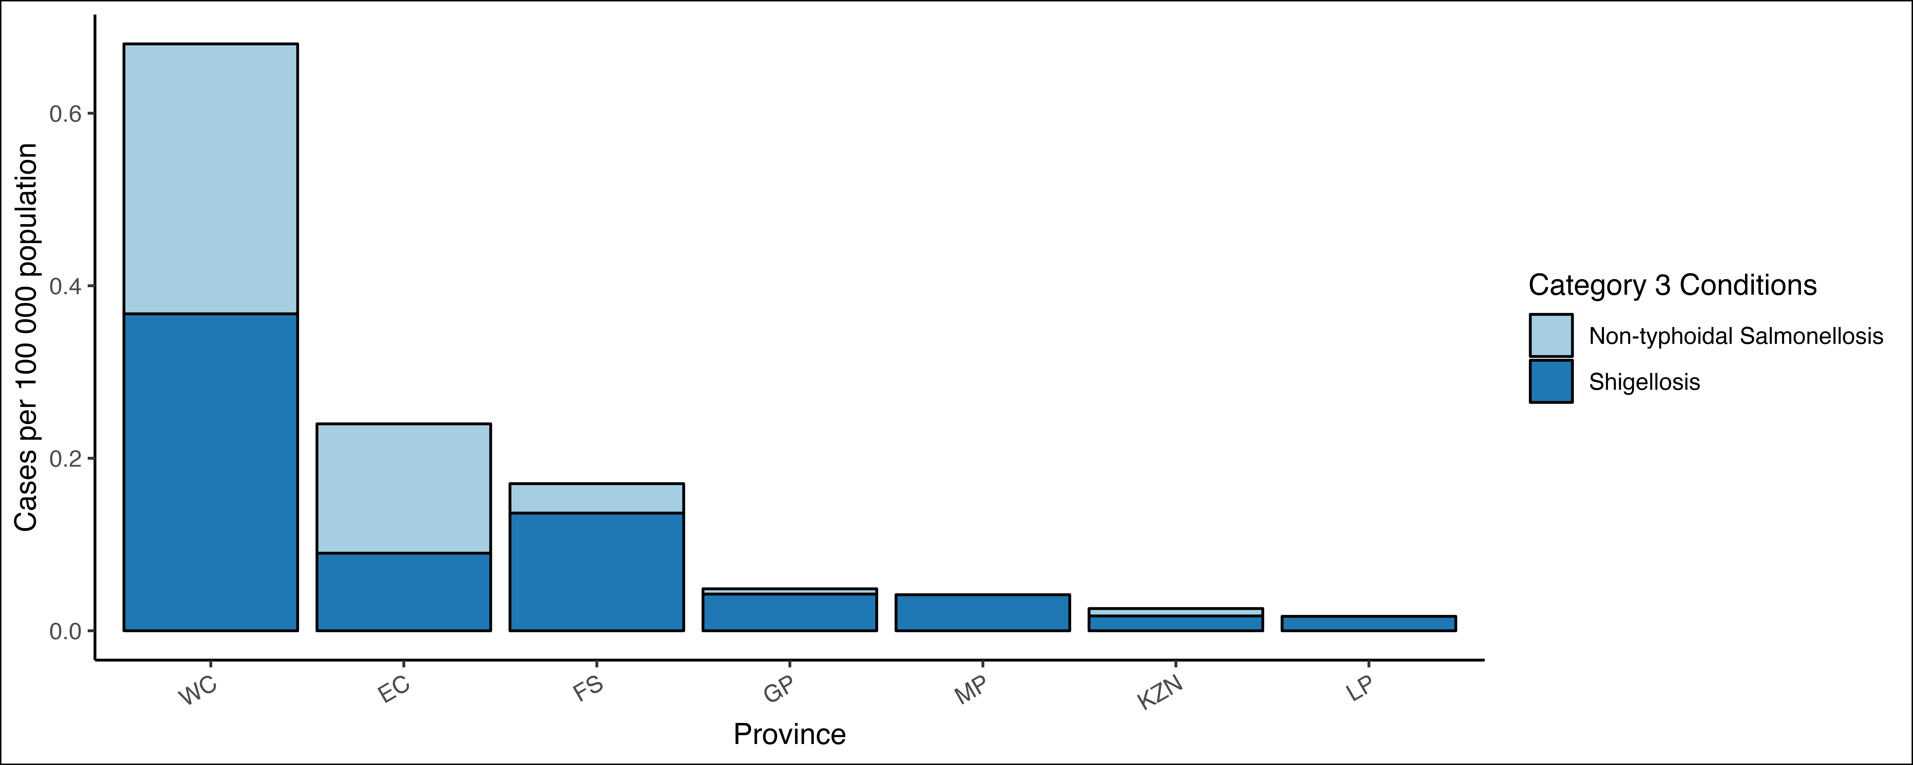

Table 13:

|  | **WC pop = 7 348 756** | | **EC pop = 6 670 455** | | **GP pop = 16 451 506** | | **FS pop = 2 931 570** | | **KZN pop = 11 646 522** | | **MP pop = 4 786 528** | | **LP pop = 5 981 583** | |
| --- | --- | --- | --- | --- | --- | --- | --- | --- | --- | --- | --- | --- | --- | --- |
| **Condition**1 | **c**1 | **i**1 | **c**1 | **i**1 | **c**1 | **i**1 | **c**1 | **i**1 | **c**1 | **i**1 | **c**1 | **i**1 | **c**1 | **i**1 |
| **Non-typhoidal Salmonellosis** | **23** | 0.31 | **10** | 0.15 | **1** | 0.01 | **1** | 0.03 | **1** | 0.01 |  | - |  | - |
| **Shigellosis** | **27** | 0.37 | **6** | 0.09 | **7** | 0.04 | **4** | 0.14 | **2** | 0.02 | **2** | 0.04 | **1** | 0.02 |
| 1c = cases, i = incidence | | | | | | | | | | | | | | |

# Cases and incidence by age category

## Category 1

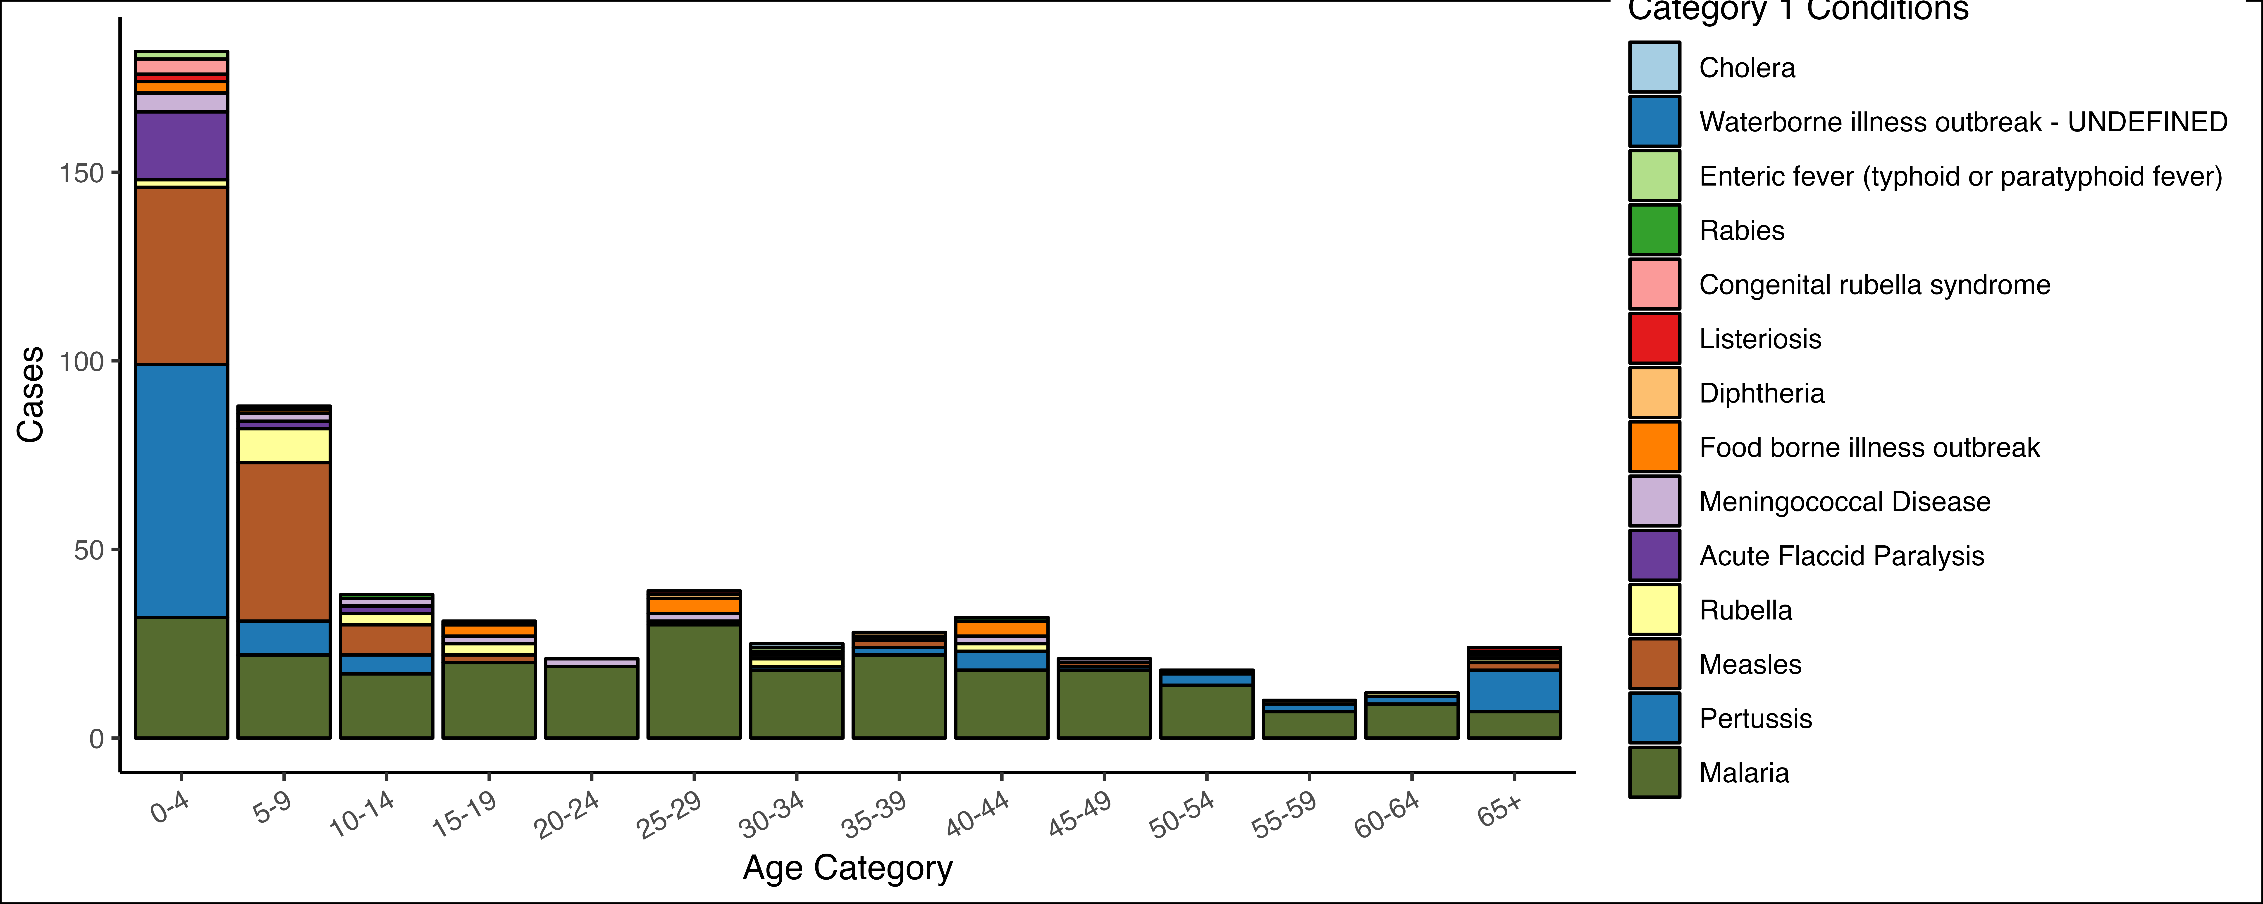

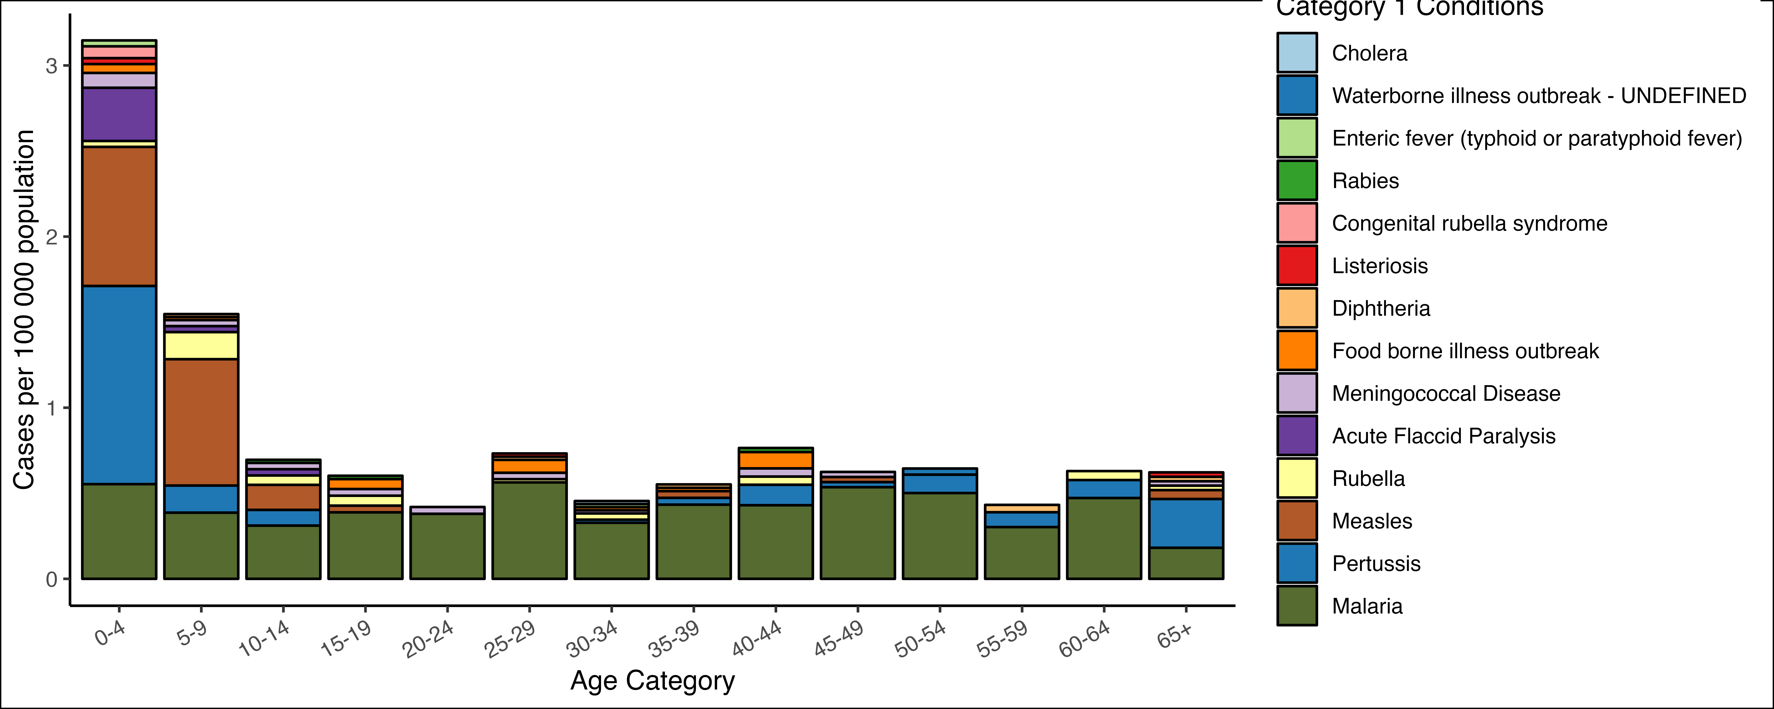

Table 14:

|  | **0-4** | | **5-9** | | **10-14** | | **15-19** | | **20-24** | | **25-29** | | **30-34** | | **35-39** | | **40-44** | | **45-49** | | **50-54** | | **55-59** | | **60-64** | | **65+** | |
| --- | --- | --- | --- | --- | --- | --- | --- | --- | --- | --- | --- | --- | --- | --- | --- | --- | --- | --- | --- | --- | --- | --- | --- | --- | --- | --- | --- | --- |
| **Condition**1 | **c**1 | **i**1 | **c**1 | **i**1 | **c**1 | **i**1 | **c**1 | **i**1 | **c**1 | **i**1 | **c**1 | **i**1 | **c**1 | **i**1 | **c**1 | **i**1 | **c**1 | **i**1 | **c**1 | **i**1 | **c**1 | **i**1 | **c**1 | **i**1 | **c**1 | **i**1 | **c**1 | **i**1 |
| **Cholera** |  | - |  | - |  | - |  | - |  | - |  | - | **1** | 0.02 |  | - |  | - |  | - |  | - |  | - |  | - |  | - |
| **Waterborne illness outbreak - UNDEFINED** |  | - |  | - |  | - |  | - |  | - |  | - |  | - |  | - |  | - |  | - | **1** | 0.04 |  | - |  | - |  | - |
| **Enteric fever (typhoid or paratyphoid fever)** | **2** | 0.03 |  | - |  | - |  | - |  | - |  | - | **1** | 0.02 |  | - |  | - |  | - |  | - |  | - |  | - |  | - |
| **Rabies** |  | - |  | - | **1** | 0.02 | **1** | 0.02 |  | - |  | - |  | - |  | - | **1** | 0.02 |  | - |  | - |  | - |  | - |  | - |
| **Congenital rubella syndrome** | **4** | 0.07 |  | - |  | - |  | - |  | - |  | - |  | - |  | - |  | - |  | - |  | - |  | - |  | - |  | - |
| **Listeriosis** | **2** | 0.03 |  | - |  | - |  | - |  | - | **1** | 0.02 |  | - |  | - |  | - |  | - |  | - |  | - |  | - | **1** | 0.03 |
| **Diphtheria** |  | - | **1** | 0.02 |  | - |  | - |  | - | **1** | 0.02 |  | - | **1** | 0.02 |  | - |  | - |  | - | **1** | 0.04 |  | - | **1** | 0.03 |
| **Food borne illness outbreak** | **3** | 0.05 | **1** | 0.02 |  | - | **3** | 0.06 |  | - | **4** | 0.08 | **1** | 0.02 | **1** | 0.02 | **4** | 0.10 |  | - |  | - |  | - |  | - |  | - |
| **Meningococcal Disease** | **5** | 0.09 | **2** | 0.04 | **2** | 0.04 | **2** | 0.04 | **2** | 0.04 | **2** | 0.04 | **1** | 0.02 |  | - | **2** | 0.05 | **1** | 0.03 |  | - |  | - |  | - | **1** | 0.03 |
| **Acute Flaccid Paralysis** | **18** | 0.31 | **2** | 0.04 | **2** | 0.04 |  | - |  | - |  | - |  | - |  | - |  | - |  | - |  | - |  | - |  | - |  | - |
| **Rubella** | **2** | 0.03 | **9** | 0.16 | **3** | 0.05 | **3** | 0.06 |  | - | **1** | 0.02 | **2** | 0.04 |  | - | **2** | 0.05 |  | - |  | - |  | - | **1** | 0.05 | **1** | 0.03 |
| **Measles** | **47** | 0.81 | **42** | 0.74 | **8** | 0.15 | **2** | 0.04 |  | - |  | - |  | - | **2** | 0.04 |  | - | **1** | 0.03 |  | - |  | - |  | - | **2** | 0.05 |
| **Pertussis** | **67** | 1.2 | **9** | 0.16 | **5** | 0.09 |  | - |  | - |  | - | **1** | 0.02 | **2** | 0.04 | **5** | 0.12 | **1** | 0.03 | **3** | 0.11 | **2** | 0.09 | **2** | 0.10 | **11** | 0.29 |
| **Malaria** | **32** | 0.55 | **22** | 0.39 | **17** | 0.31 | **20** | 0.39 | **19** | 0.38 | **30** | 0.56 | **18** | 0.33 | **22** | 0.43 | **18** | 0.43 | **18** | 0.54 | **14** | 0.50 | **7** | 0.30 | **9** | 0.47 | **7** | 0.18 |
| 1c = cases, i = incidence | | | | | | | | | | | | | | | | | | | | | | | | | | | | |

## Category 2

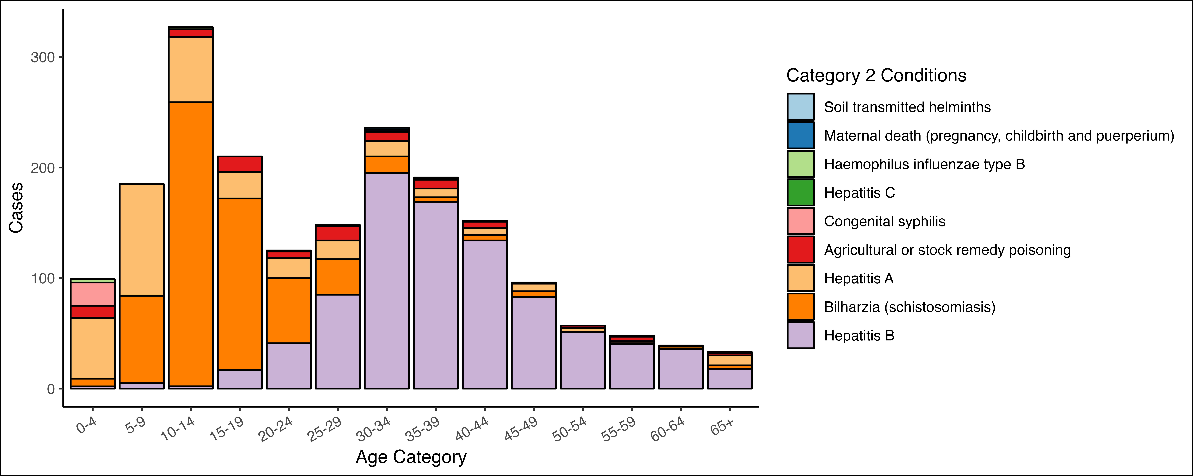

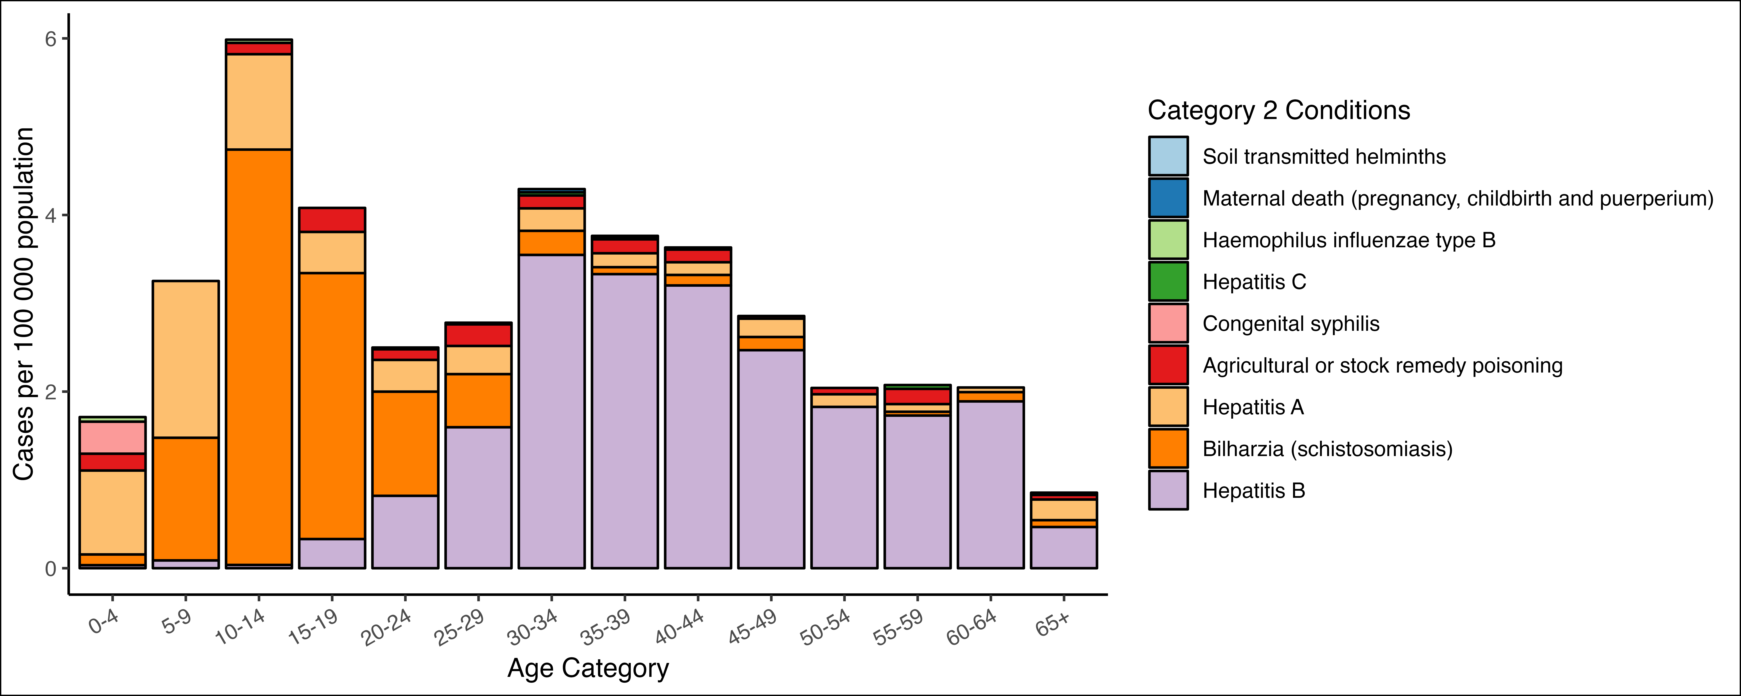

Table 15:

|  | **0-4** | | **5-9** | | **10-14** | | **15-19** | | **20-24** | | **25-29** | | **30-34** | | **35-39** | | **40-44** | | **45-49** | | **50-54** | | **55-59** | | **60-64** | | **65+** | |
| --- | --- | --- | --- | --- | --- | --- | --- | --- | --- | --- | --- | --- | --- | --- | --- | --- | --- | --- | --- | --- | --- | --- | --- | --- | --- | --- | --- | --- |
| **Condition**1 | **c**1 | **i**1 | **c**1 | **i**1 | **c**1 | **i**1 | **c**1 | **i**1 | **c**1 | **i**1 | **c**1 | **i**1 | **c**1 | **i**1 | **c**1 | **i**1 | **c**1 | **i**1 | **c**1 | **i**1 | **c**1 | **i**1 | **c**1 | **i**1 | **c**1 | **i**1 | **c**1 | **i**1 |
| **Soil transmitted helminths** |  | - |  | - |  | - |  | - |  | - |  | - |  | - |  | - | **1** | 0.02 |  | - |  | - |  | - |  | - |  | - |
| **Maternal death (pregnancy, childbirth and puerperium)** |  | - |  | - |  | - |  | - | **1** | 0.02 |  | - | **2** | 0.04 | **1** | 0.02 |  | - |  | - |  | - |  | - |  | - |  | - |
| **Haemophilus influenzae type B** | **3** | 0.05 |  | - | **2** | 0.04 |  | - |  | - |  | - |  | - |  | - |  | - |  | - |  | - |  | - |  | - |  | - |
| **Hepatitis C** |  | - |  | - |  | - |  | - |  | - | **1** | 0.02 | **2** | 0.04 | **1** | 0.02 |  | - |  | - |  | - | **1** | 0.04 |  | - | **1** | 0.03 |
| **Congenital syphilis** | **21** | 0.36 |  | - |  | - |  | - |  | - |  | - |  | - |  | - |  | - |  | - |  | - |  | - |  | - |  | - |
| **Agricultural or stock remedy poisoning** | **11** | 0.19 |  | - | **7** | 0.13 | **14** | 0.27 | **6** | 0.12 | **13** | 0.24 | **8** | 0.15 | **8** | 0.16 | **6** | 0.14 | **1** | 0.03 | **2** | 0.07 | **4** | 0.17 |  | - | **2** | 0.05 |
| **Hepatitis A** | **55** | 0.95 | **101** | 1.8 | **59** | 1.1 | **24** | 0.47 | **18** | 0.36 | **17** | 0.32 | **14** | 0.25 | **8** | 0.16 | **6** | 0.14 | **7** | 0.21 | **4** | 0.14 | **2** | 0.09 | **1** | 0.05 | **9** | 0.23 |
| **Bilharzia (schistosomiasis)** | **7** | 0.12 | **79** | 1.4 | **257** | 4.7 | **155** | 3.0 | **59** | 1.2 | **32** | 0.60 | **15** | 0.27 | **4** | 0.08 | **5** | 0.12 | **5** | 0.15 |  | - | **1** | 0.04 | **2** | 0.10 | **3** | 0.08 |
| **Hepatitis B** | **2** | 0.03 | **5** | 0.09 | **2** | 0.04 | **17** | 0.33 | **41** | 0.82 | **85** | 1.6 | **195** | 3.5 | **169** | 3.3 | **134** | 3.2 | **83** | 2.5 | **51** | 1.8 | **40** | 1.7 | **36** | 1.9 | **18** | 0.47 |
| 1c = cases, i = incidence | | | | | | | | | | | | | | | | | | | | | | | | | | | | |

## Category 3

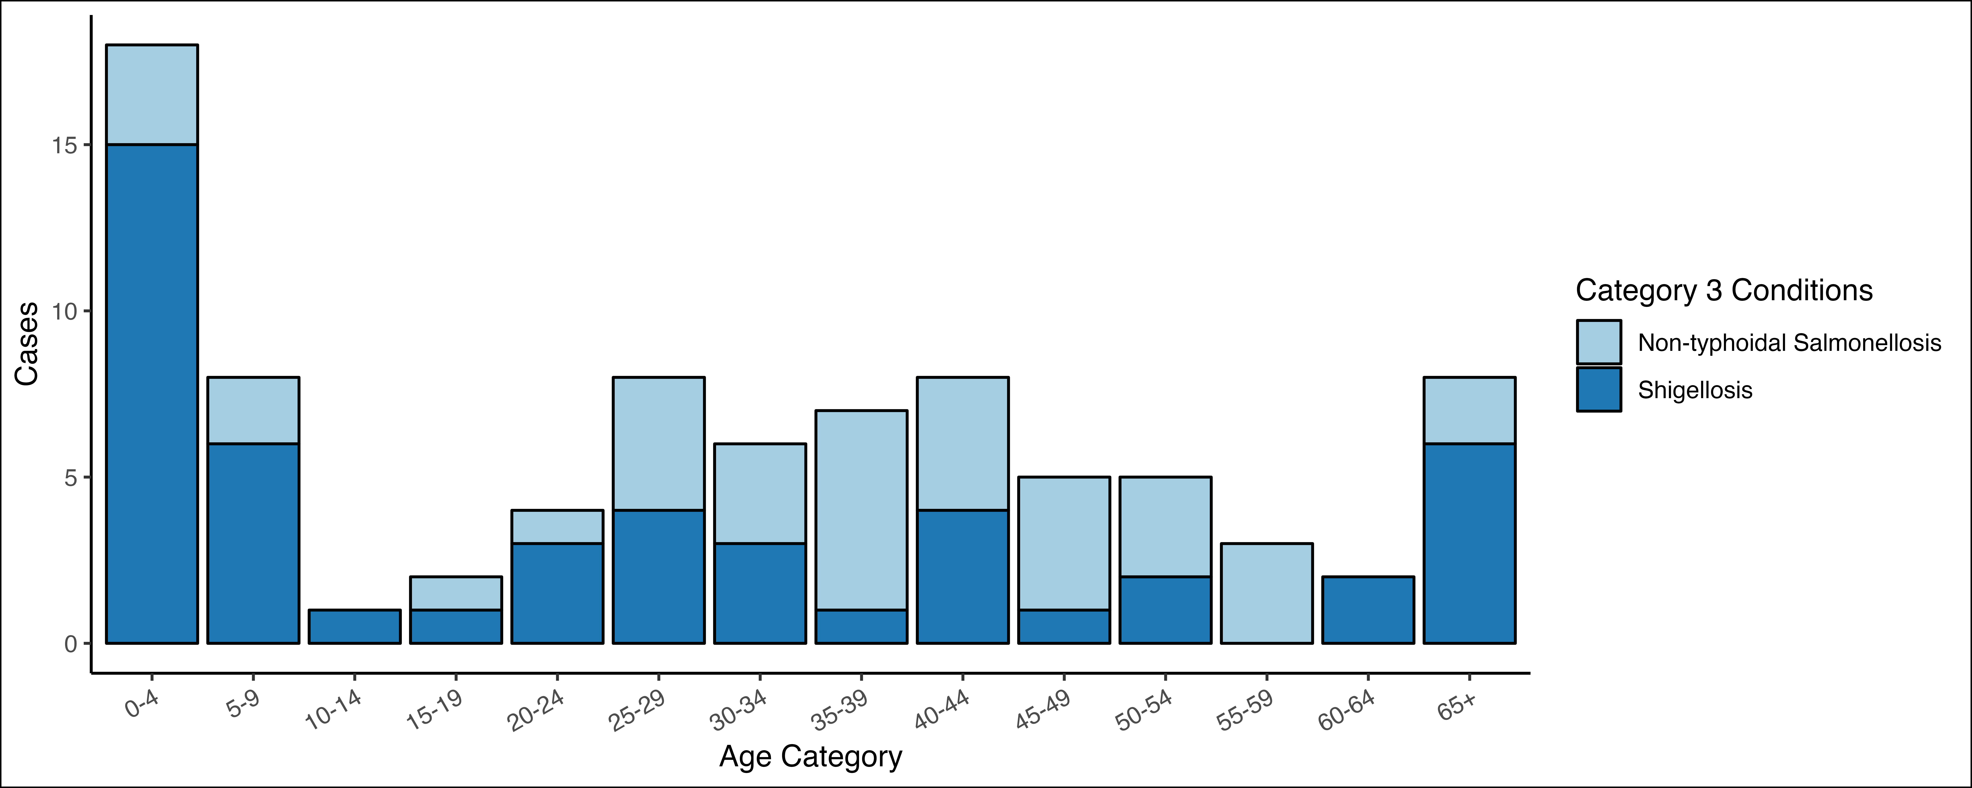

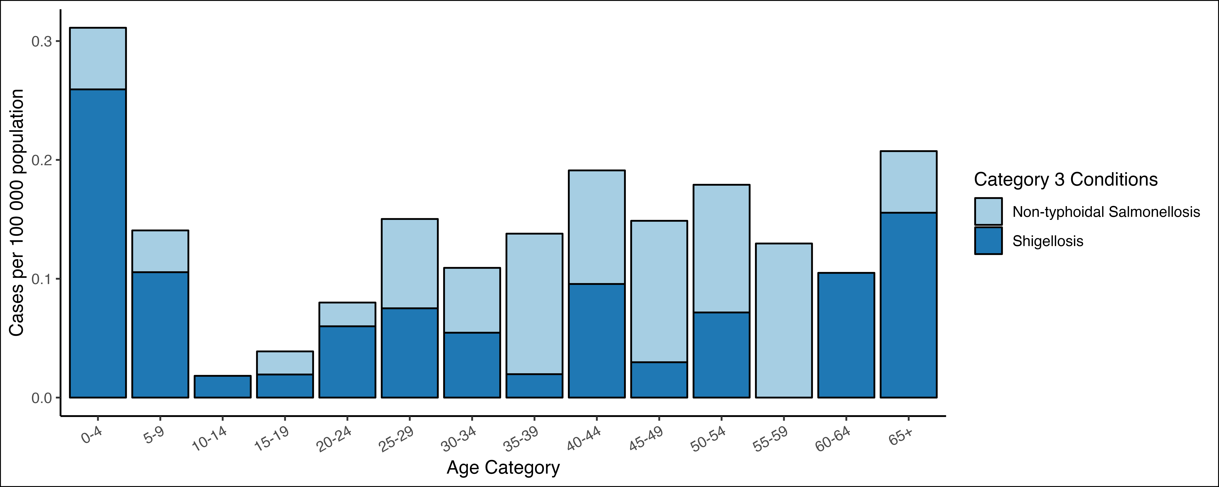

Table 16:

|  | **0-4** | | **5-9** | | **10-14** | | **15-19** | | **20-24** | | **25-29** | | **30-34** | | **35-39** | | **40-44** | | **45-49** | | **50-54** | | **55-59** | | **60-64** | | **65+** | |
| --- | --- | --- | --- | --- | --- | --- | --- | --- | --- | --- | --- | --- | --- | --- | --- | --- | --- | --- | --- | --- | --- | --- | --- | --- | --- | --- | --- | --- |
| **Condition**1 | **c**1 | **i**1 | **c**1 | **i**1 | **c**1 | **i**1 | **c**1 | **i**1 | **c**1 | **i**1 | **c**1 | **i**1 | **c**1 | **i**1 | **c**1 | **i**1 | **c**1 | **i**1 | **c**1 | **i**1 | **c**1 | **i**1 | **c**1 | **i**1 | **c**1 | **i**1 | **c**1 | **i**1 |
| **Non-typhoidal Salmonellosis** | **3** | 0.05 | **2** | 0.04 |  | - | **1** | 0.02 | **1** | 0.02 | **4** | 0.08 | **3** | 0.05 | **6** | 0.12 | **4** | 0.10 | **4** | 0.12 | **3** | 0.11 | **3** | 0.13 |  | - | **2** | 0.05 |
| **Shigellosis** | **15** | 0.26 | **6** | 0.11 | **1** | 0.02 | **1** | 0.02 | **3** | 0.06 | **4** | 0.08 | **3** | 0.05 | **1** | 0.02 | **4** | 0.10 | **1** | 0.03 | **2** | 0.07 |  | - | **2** | 0.10 | **6** | 0.16 |
| 1c = cases, i = incidence | | | | | | | | | | | | | | | | | | | | | | | | | | | | |

# Tuberclusosis

## Cases and Incidence by province

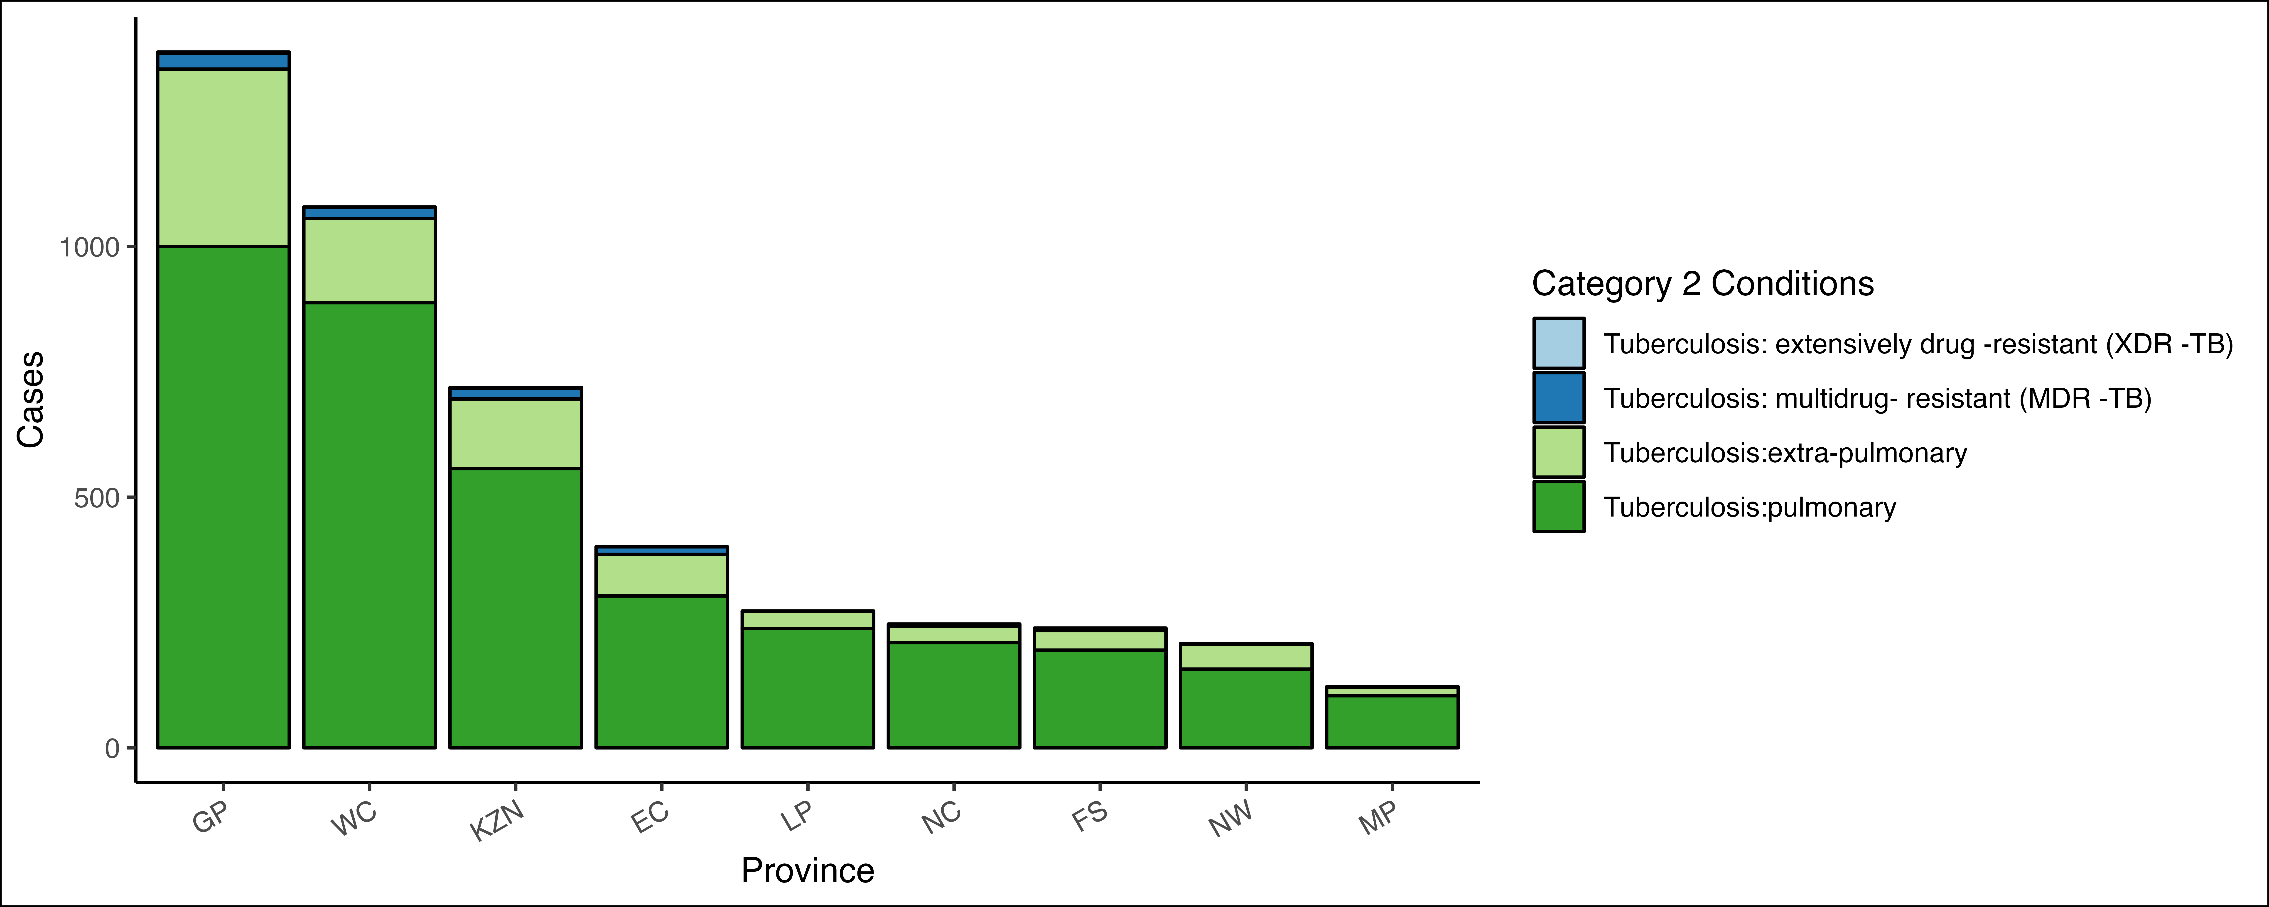

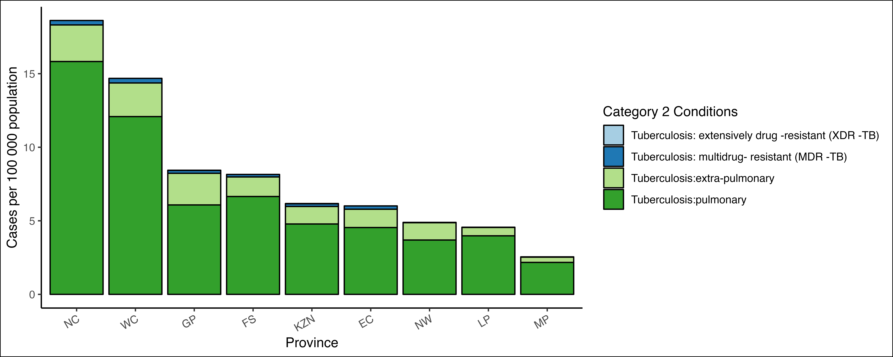

Table 17:

|  | **GP pop = 16 451 506** | | **WC pop = 7 348 756** | | **KZN pop = 11 646 522** | | **EC pop = 6 670 455** | | **LP pop = 5 981 583** | | **NC pop = 1 326 746** | | **FS pop = 2 931 570** | | **NW pop = 4 251 241** | | **MP pop = 4 786 528** | |
| --- | --- | --- | --- | --- | --- | --- | --- | --- | --- | --- | --- | --- | --- | --- | --- | --- | --- | --- |
| **Condition**1 | **c**1 | **i**1 | **c**1 | **i**1 | **c**1 | **i**1 | **c**1 | **i**1 | **c**1 | **i**1 | **c**1 | **i**1 | **c**1 | **i**1 | **c**1 | **i**1 | **c**1 | **i**1 |
| **Tuberculosis: extensively drug -resistant (XDR -TB)** | **2** | 0.01 |  | - | **2** | 0.02 |  | - |  | - |  | - |  | - |  | - |  | - |
| **Tuberculosis: multidrug- resistant (MDR -TB)** | **32** | 0.19 | **23** | 0.31 | **21** | 0.18 | **15** | 0.22 | **1** | 0.02 | **4** | 0.30 | **5** | 0.17 | **1** | 0.02 | **1** | 0.02 |
| **Tuberculosis:extra-pulmonary** | **354** | 2.2 | **168** | 2.3 | **139** | 1.2 | **83** | 1.2 | **34** | 0.57 | **33** | 2.5 | **39** | 1.3 | **50** | 1.2 | **17** | 0.36 |
| **Tuberculosis:pulmonary** |  | 6.1 | **888** | 12 | **557** | 4.8 | **303** | 4.5 | **238** | 4.0 | **210** | 16 | **195** | 6.7 | **157** | 3.7 | **104** | 2.2 |
| 1c = cases, i = incidence | | | | | | | | | | | | | | | | | | |

## Cases and incidence by Age

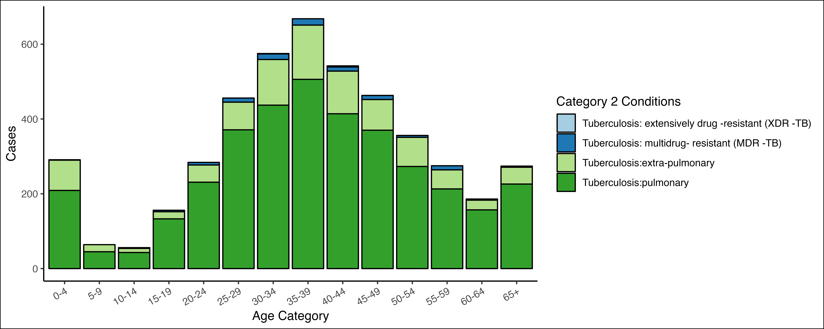

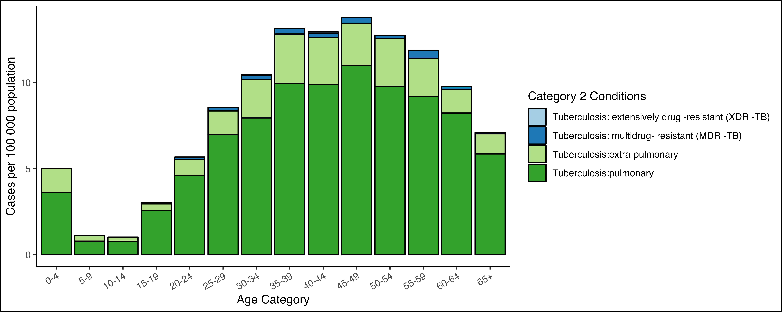

Table 18:

|  | **0-4** | | **5-9** | | **10-14** | | **15-19** | | **20-24** | | **25-29** | | **30-34** | | **35-39** | | **40-44** | | **45-49** | | **50-54** | | **55-59** | | **60-64** | | **65+** | |
| --- | --- | --- | --- | --- | --- | --- | --- | --- | --- | --- | --- | --- | --- | --- | --- | --- | --- | --- | --- | --- | --- | --- | --- | --- | --- | --- | --- | --- |
| **Condition**1 | **c**1 | **i**1 | **c**1 | **i**1 | **c**1 | **i**1 | **c**1 | **i**1 | **c**1 | **i**1 | **c**1 | **i**1 | **c**1 | **i**1 | **c**1 | **i**1 | **c**1 | **i**1 | **c**1 | **i**1 | **c**1 | **i**1 | **c**1 | **i**1 | **c**1 | **i**1 | **c**1 | **i**1 |
| **Tuberculosis: extensively drug -resistant (XDR -TB)** |  | - |  | - |  | - |  | - |  | - |  | - | **1** | 0.02 |  | - | **3** | 0.07 |  | - |  | - |  | - |  | - |  | - |
| **Tuberculosis: multidrug- resistant (MDR -TB)** | **1** | 0.02 |  | - | **2** | 0.04 | **4** | 0.08 | **7** | 0.14 | **11** | 0.21 | **15** | 0.27 | **17** | 0.33 | **11** | 0.26 | **11** | 0.33 | **5** | 0.18 | **11** | 0.48 | **3** | 0.16 | **3** | 0.08 |
| **Tuberculosis:extra-pulmonary** | **81** | 1.4 | **19** | 0.33 | **11** | 0.20 | **19** | 0.37 | **46** | 0.92 | **74** | 1.4 | **122** | 2.2 | **145** | 2.9 | **114** | 2.7 | **82** | 2.4 | **78** | 2.8 | **51** | 2.2 | **26** | 1.4 | **45** | 1.2 |
| **Tuberculosis:pulmonary** | **209** | 3.6 | **45** | 0.79 | **43** | 0.79 | **133** | 2.6 | **231** | 4.6 | **371** | 7.0 | **437** | 8.0 | **506** | 10 | **414** | 9.9 | **370** | 11 | **273** | 9.8 | **213** | 9.2 | **157** | 8.2 | **226** | 5.9 |
| 1c = cases, i = incidence | | | | | | | | | | | | | | | | | | | | | | | | | | | | |

# Hepatitis

## Cases and incidence by Province

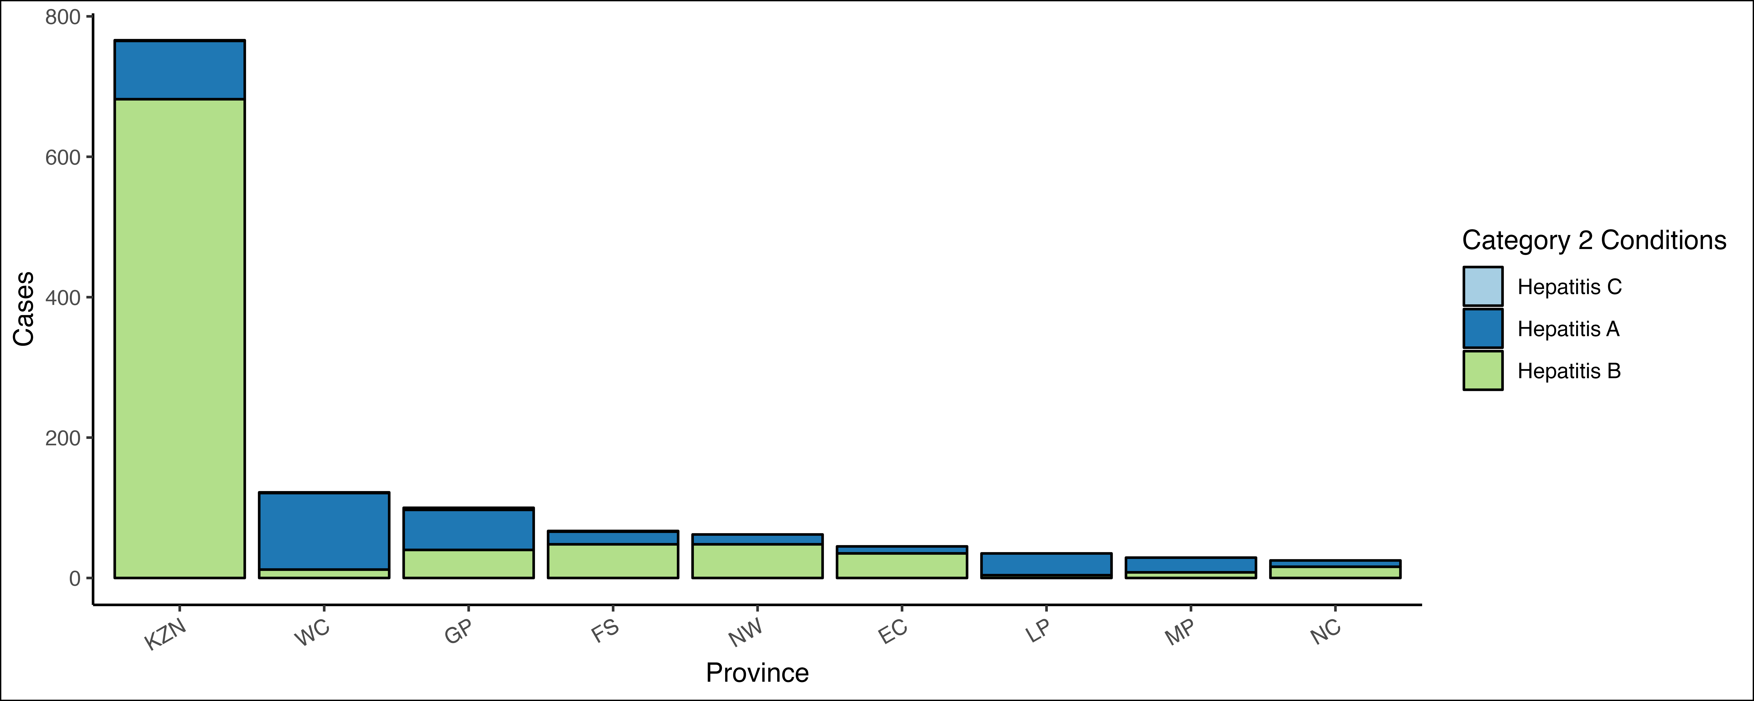

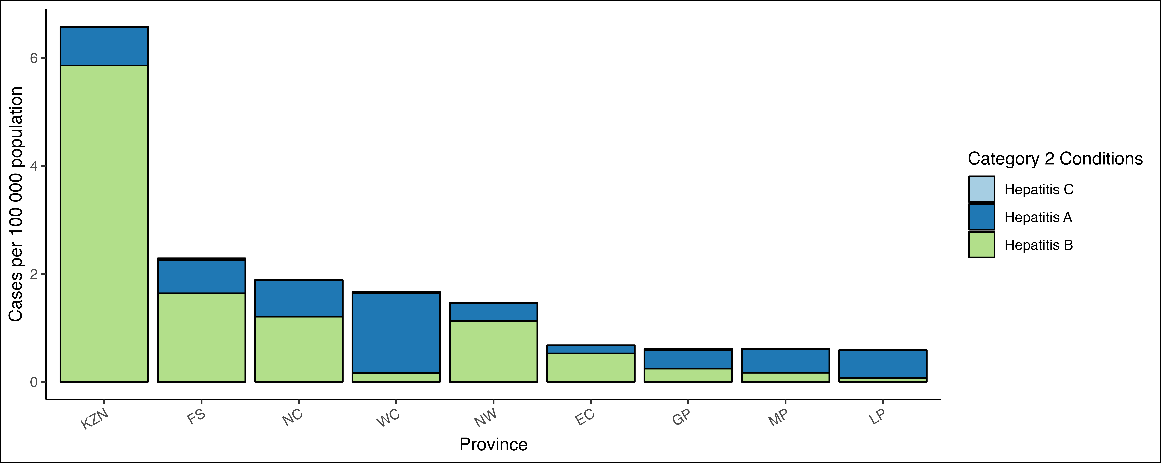

Table 19:

|  | **KZN pop = 11 646 522** | | **WC pop = 7 348 756** | | **GP pop = 16 451 506** | | **FS pop = 2 931 570** | | **NW pop = 4 251 241** | | **EC pop = 6 670 455** | | **LP pop = 5 981 583** | | **MP pop = 4 786 528** | | **NC pop = 1 326 746** | |
| --- | --- | --- | --- | --- | --- | --- | --- | --- | --- | --- | --- | --- | --- | --- | --- | --- | --- | --- |
| **Condition**1 | **c**1 | **i**1 | **c**1 | **i**1 | **c**1 | **i**1 | **c**1 | **i**1 | **c**1 | **i**1 | **c**1 | **i**1 | **c**1 | **i**1 | **c**1 | **i**1 | **c**1 | **i**1 |
| **Hepatitis C** | **1** | 0.01 | **1** | 0.01 | **3** | 0.02 | **1** | 0.03 |  | - |  | - |  | - |  | - |  | - |
| **Hepatitis A** | **83** | 0.71 | **109** | 1.5 | **57** | 0.35 | **18** | 0.61 | **14** | 0.33 | **10** | 0.15 | **31** | 0.52 | **21** | 0.44 | **9** | 0.68 |
| **Hepatitis B** | **682** | 5.9 | **12** | 0.16 | **40** | 0.24 | **48** | 1.6 | **48** | 1.1 | **35** | 0.52 | **4** | 0.07 | **8** | 0.17 | **16** | 1.2 |
| 1c = cases, i = incidence | | | | | | | | | | | | | | | | | | |

## Cases and incidence by Age category

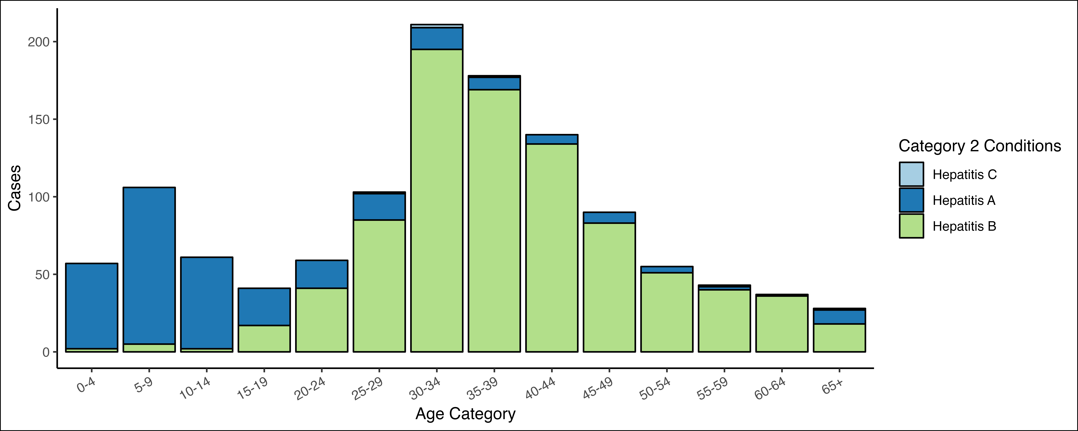

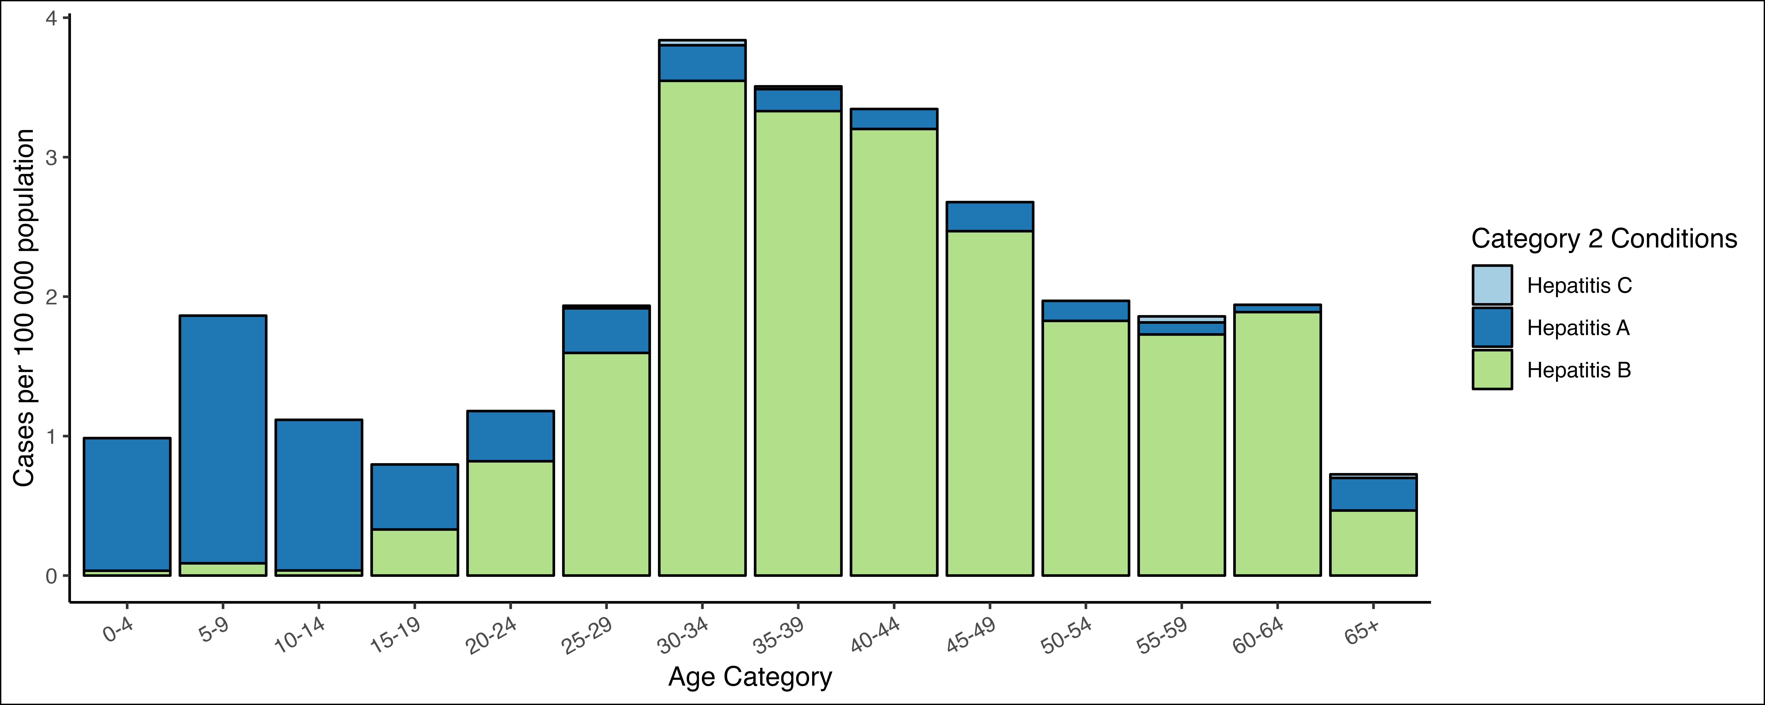

Table 20:

|  | **0-4** | | **5-9** | | **10-14** | | **15-19** | | **20-24** | | **25-29** | | **30-34** | | **35-39** | | **40-44** | | **45-49** | | **50-54** | | **55-59** | | **60-64** | | **65+** | |
| --- | --- | --- | --- | --- | --- | --- | --- | --- | --- | --- | --- | --- | --- | --- | --- | --- | --- | --- | --- | --- | --- | --- | --- | --- | --- | --- | --- | --- |
| **Condition**1 | **c**1 | **i**1 | **c**1 | **i**1 | **c**1 | **i**1 | **c**1 | **i**1 | **c**1 | **i**1 | **c**1 | **i**1 | **c**1 | **i**1 | **c**1 | **i**1 | **c**1 | **i**1 | **c**1 | **i**1 | **c**1 | **i**1 | **c**1 | **i**1 | **c**1 | **i**1 | **c**1 | **i**1 |
| **Hepatitis C** |  | - |  | - |  | - |  | - |  | - | **1** | 0.02 | **2** | 0.04 | **1** | 0.02 |  | - |  | - |  | - | **1** | 0.04 |  | - | **1** | 0.03 |
| **Hepatitis A** | **55** | 0.95 | **101** | 1.8 | **59** | 1.1 | **24** | 0.47 | **18** | 0.36 | **17** | 0.32 | **14** | 0.25 | **8** | 0.16 | **6** | 0.14 | **7** | 0.21 | **4** | 0.14 | **2** | 0.09 | **1** | 0.05 | **9** | 0.23 |
| **Hepatitis B** | **2** | 0.03 | **5** | 0.09 | **2** | 0.04 | **17** | 0.33 | **41** | 0.82 | **85** | 1.6 | **195** | 3.5 | **169** | 3.3 | **134** | 3.2 | **83** | 2.5 | **51** | 1.8 | **40** | 1.7 | **36** | 1.9 | **18** | 0.47 |
| 1c = cases, i = incidence | | | | | | | | | | | | | | | | | | | | | | | | | | | | |

**END**